*Submitted by*

*BHAVIN P V*

**Contents**

**1. SVN** **Basics 3**

1.1 Introduction 3

1.2 Basic Uses 4

**2. Building** **, Flashing and Debugging** 10

2.1 Building 10

2.2 Flashing and Debugging 12

**3. Release** **Folder 20**

3.1 Introduction 20

3.2 To Create pdx 20

3.3 vflashpack 23

3.4 Flashing using vflashpack 27

3.5 Release 27

**3. dbc** **and cdd 28**

4.1 Vector CANdb++ Editor 28

4.2 DBC file 28

4.3 Vector CANdela Studio 32

4.4 CDD file 32

**CHAPTER 1**

# 1. SVN Basics

## 1.1 Introduction

SVN stands for Subversion, which is a version control system used for managing and tracking changes to files and directories. It allows multiple developers to work on the same set of files concurrently and keeps track of all changes made to the files.

With SVN, developers can check out a copy of a project from a central repository onto their local machines. They can make modifications to the files, add new files, and remove existing files. Subversion keeps track of these changes and allows users to commit them back to the repository.

Tortoise SVN is the graphical client we used for SVN. Once you download the client we will be able to see the Tortoise SVN on right click and get its features.

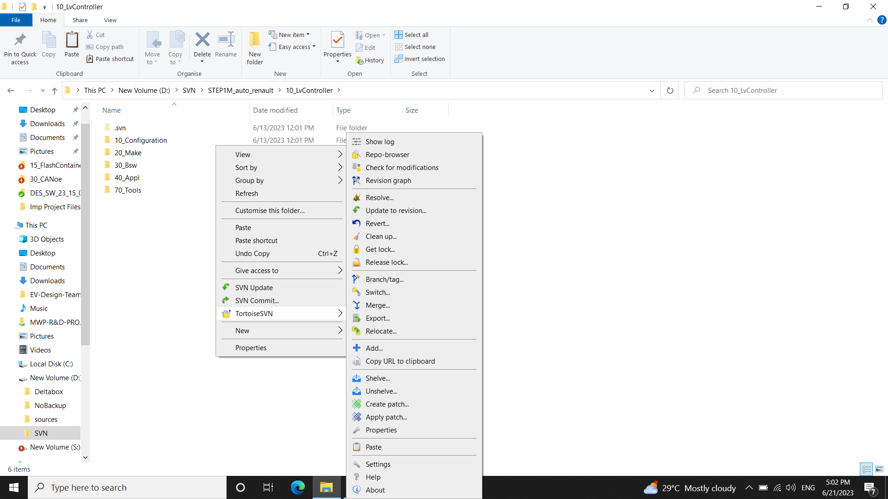

## 1.2 Basic Uses

SVN Repository Browser

It allows users to browse and navigate through the directory structure of an SVN repository. It provides a hierarchical view of files and folders stored in the repository, giving users an overview of the project's structure.

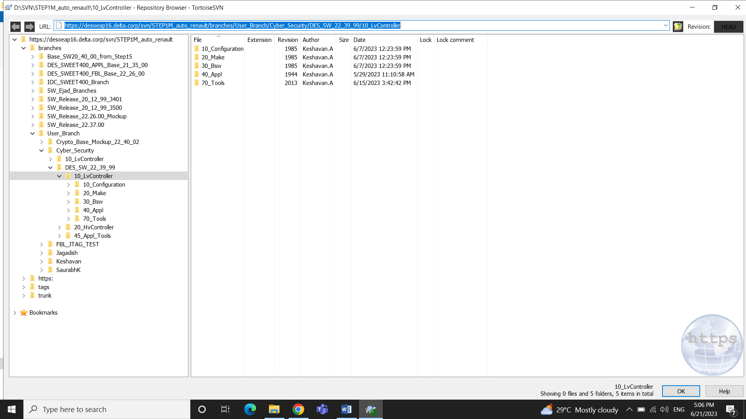

SVN Checkout

To Download the Repository into the local machine to get a working copy. In order to checkout we will open the SVN Repository Browser where we will type the URL.

Select **SVN Checkout** > Type in the URL and the path where it is to be downloaded.

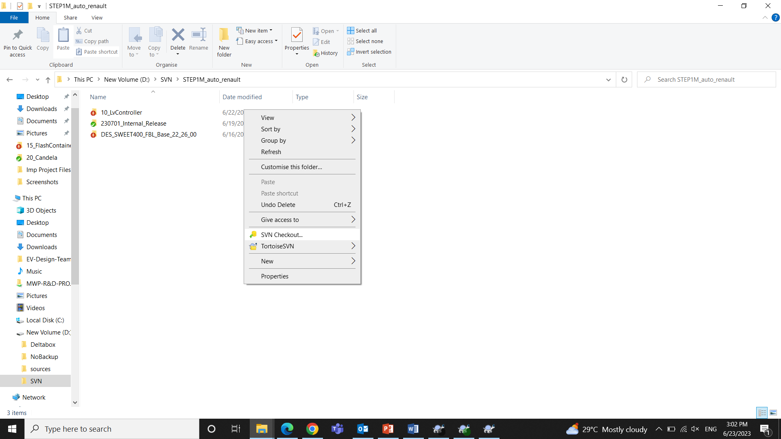

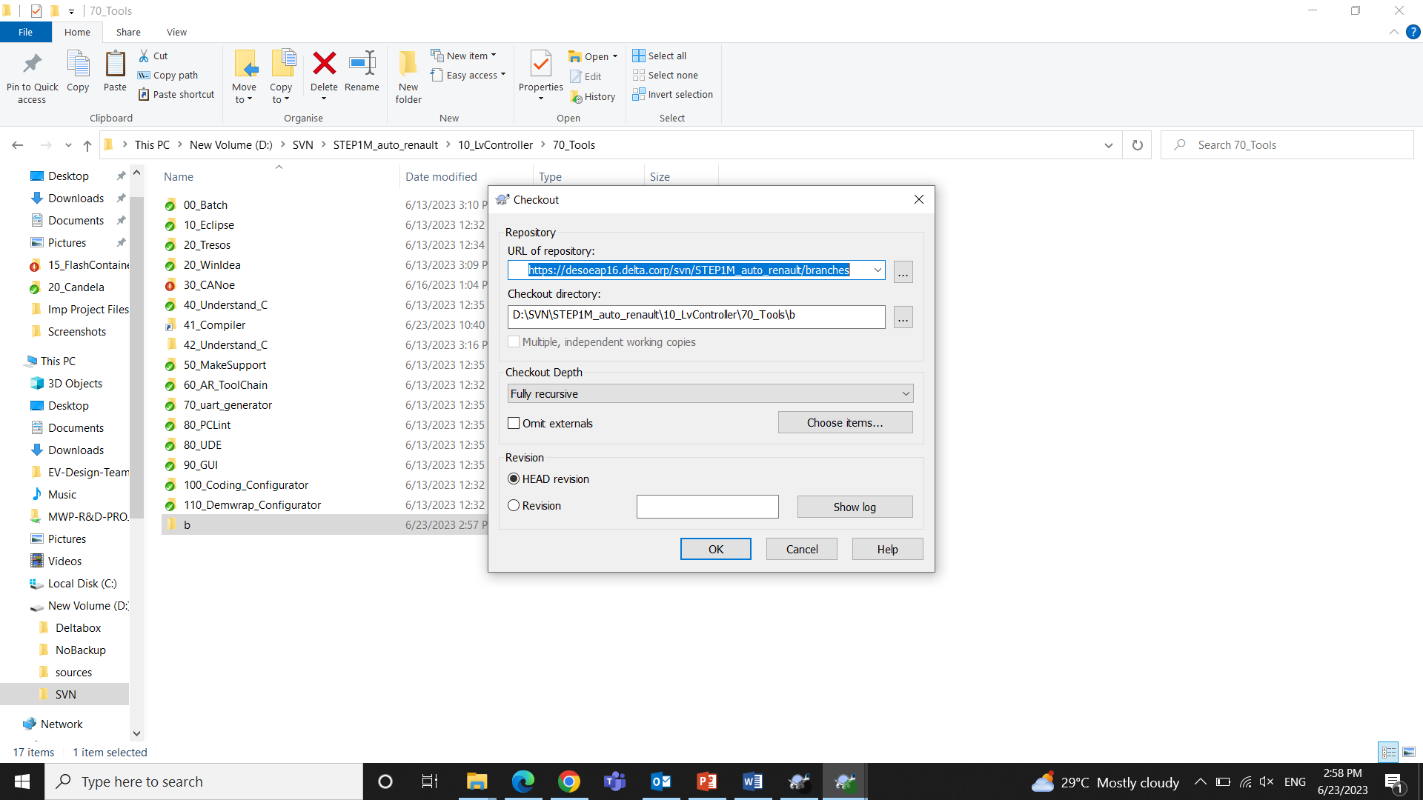

SVN Update

To Update the checked out Repository to the latest version.

Conflict

While Updating the SVN Repo, there may be cases of Conflicts.

Some files may be conflicted, which means that those files have a different version in our local repository. Such files may be edited by others who are co working in the Repo and committed to the server but we didn’t commit we made the changes locally.

Conflict is actually in the working copy.

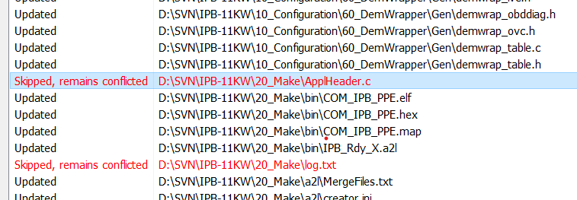

Resolving the Conflicts

When we right click on the conflict, we get options to edit and resolve the conflicts.

On clicking Edit Conflicts

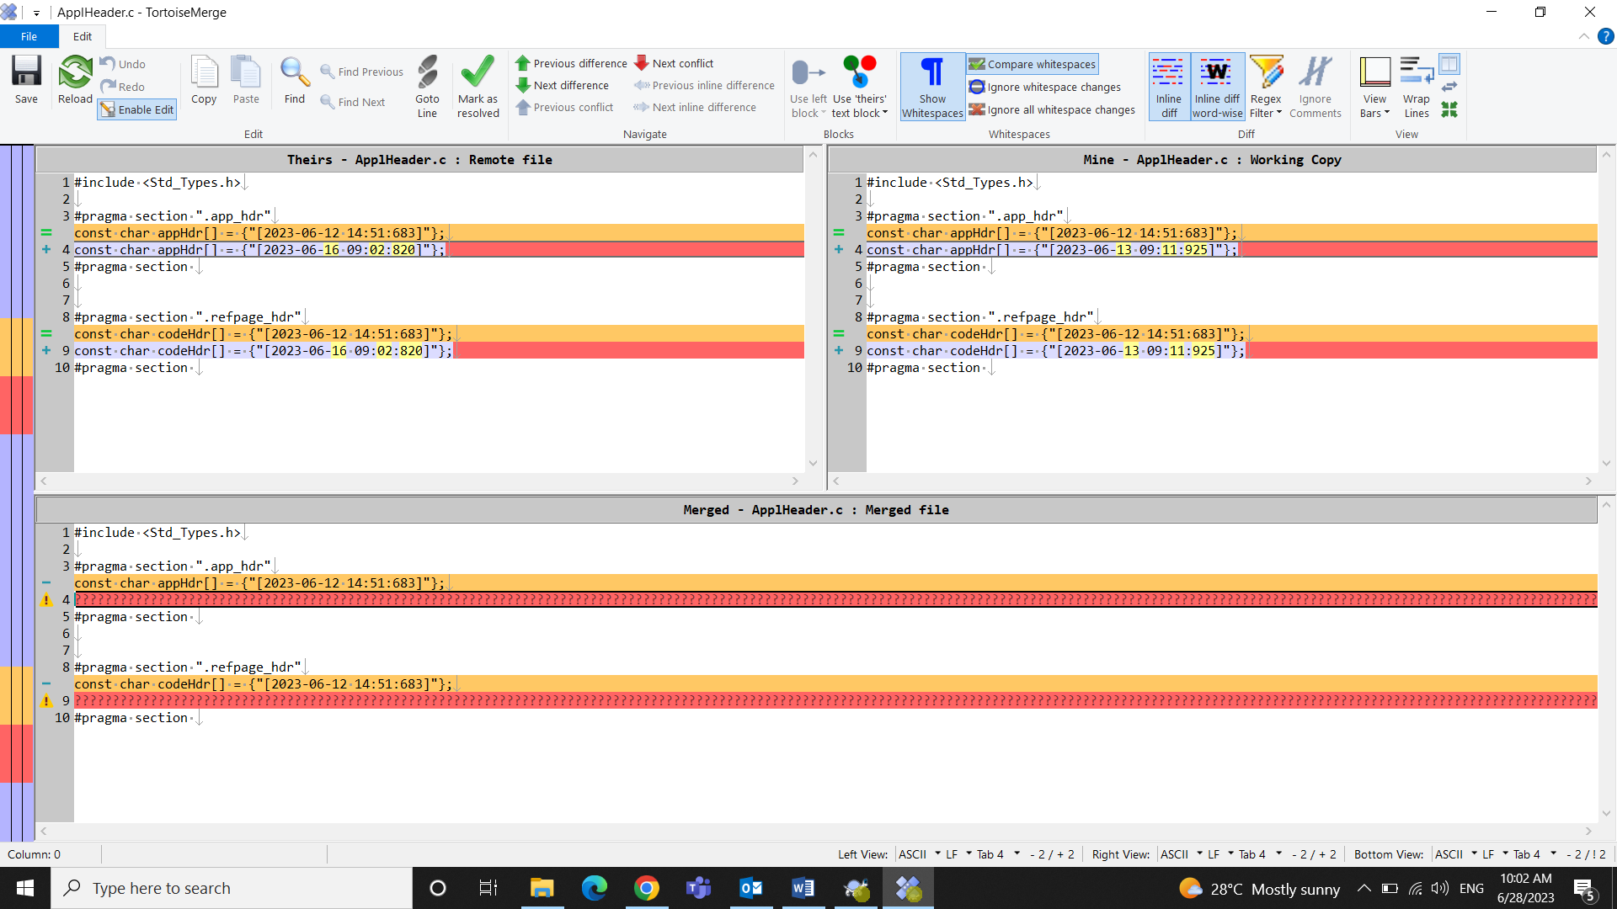

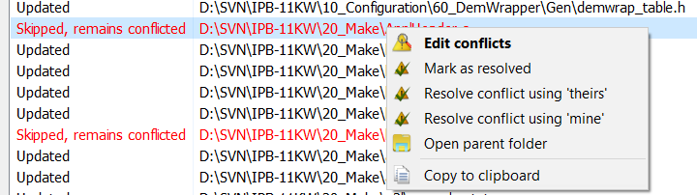

**Mark as Resolved**: Ignoring the conflict.

**Resolve conflict using theirs**: Locally their update in the file will be preferred and my working copy will have those.

**Resolve conflict using mine**: Locally the changes made by me will be preferred and my working copy will have those, even though what is committed stays there in the server.

SVN Commit

To commit the changes did in working copy of the repository into the server.

When we move to the path where we made changes, then on selecting SVN commit, it will show the changes made in the files of that path.

We don’t need to add (.d) files as they are dependency files, that doesn’t need to Commit.

Add the message and Click OK to commit the changes.

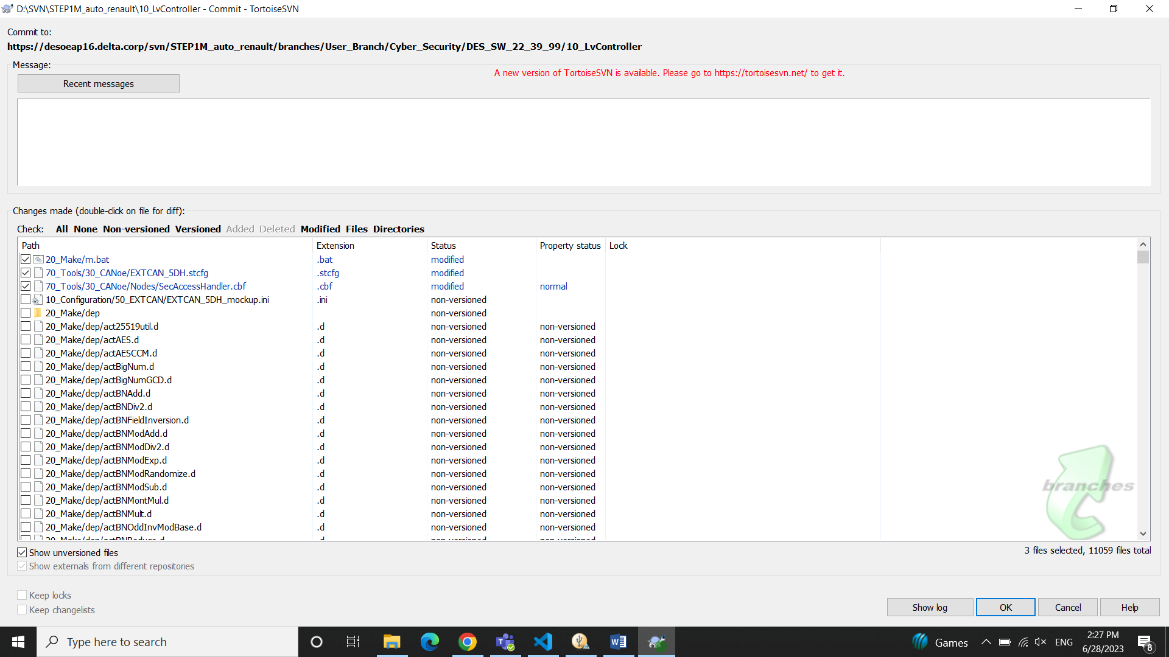

Show logs

To see the logs i.e. to see what all revisions happened in the repository. It contains the Revision No, Author who did the revision, time, date, messages. It also contains the path where changes happened in each revision we can compare the changes in each revision.

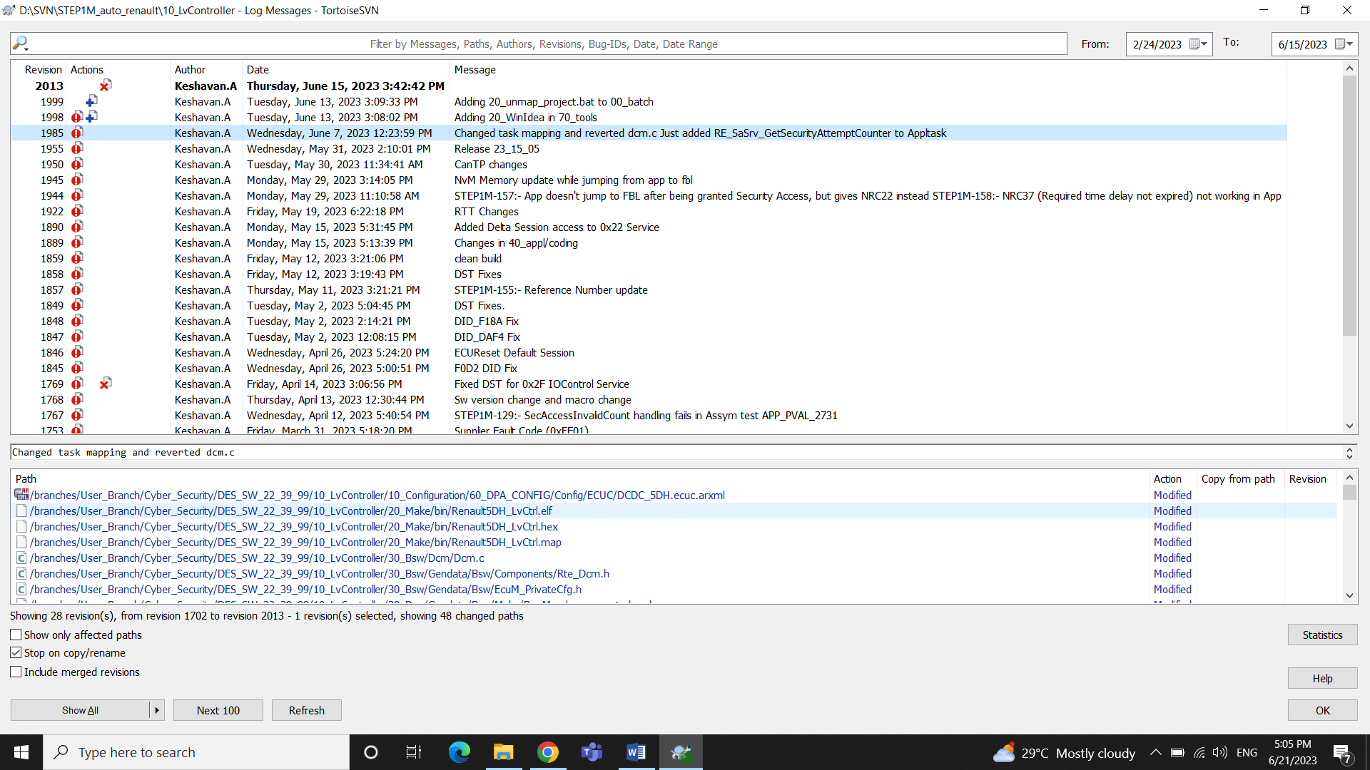

We can compare the changes on clicking the file in path console

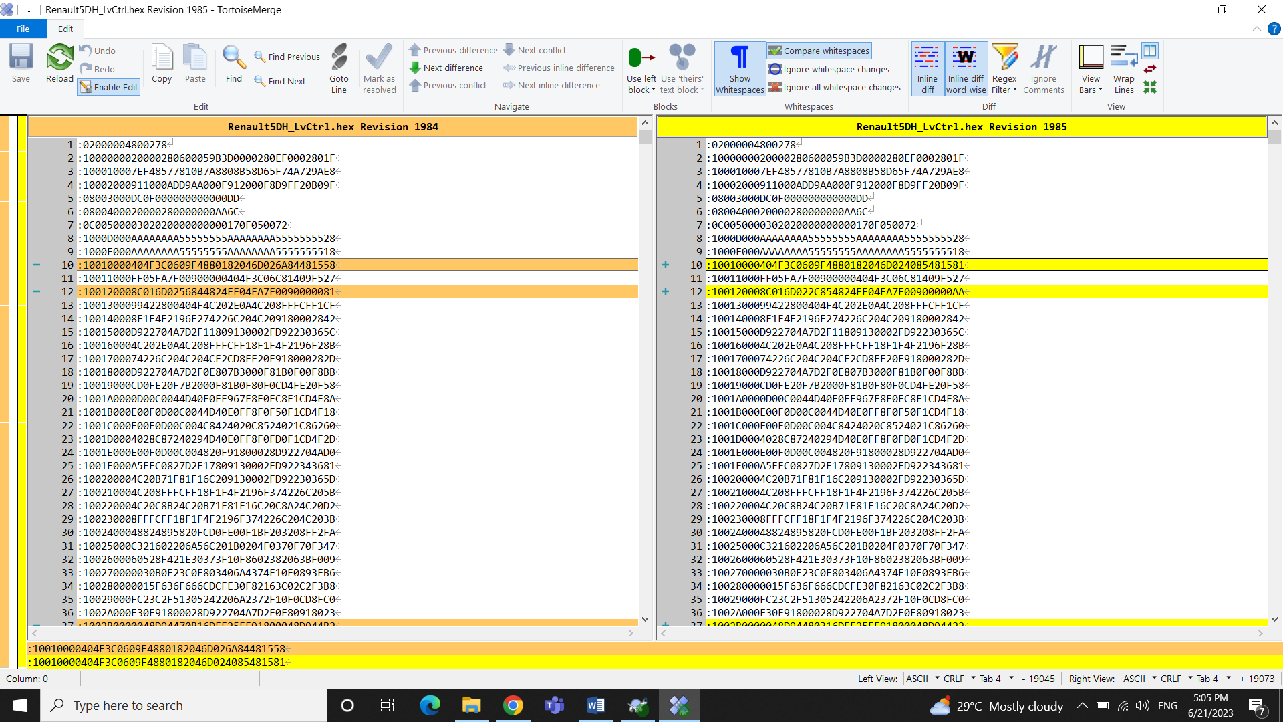

Check for Modifications

To identify the files and folders that have been modified in your working copy compared to the repository.

Update to Revision

We can move back to any previous revisions i.e. It allows you to roll back your working copy to a previous state and retrieve the files and directories as they existed at that revision. But make sure that any modifications made are backed up if you need them.

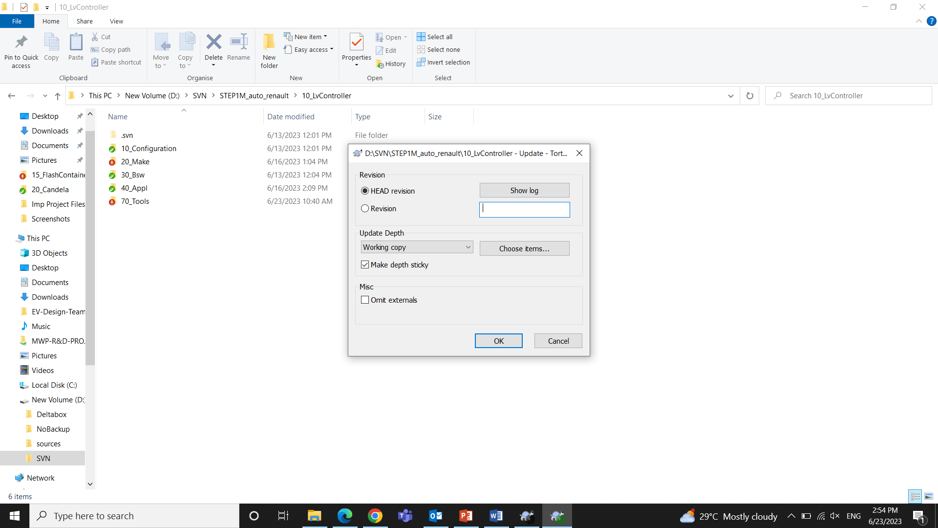

You can give the Revision number by looking to the logs.

Cleanup

While doing SVN Update, the update window sometimes asks you to cleanup.

Cleanup is used to resolve issues related to your working copy.

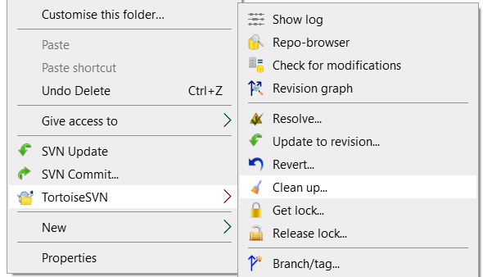

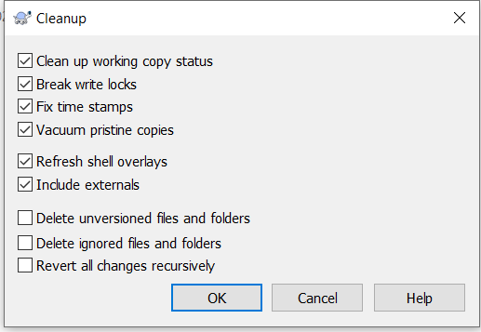

Make sure you don’t check the **delete options** unless you have a backup

Revert

To undo all the local changes done in the working copy.

Get Lock

To lock while making changes in the trunk so that no other can interfere parallel.

Add

To add any new files or folders into the Repository

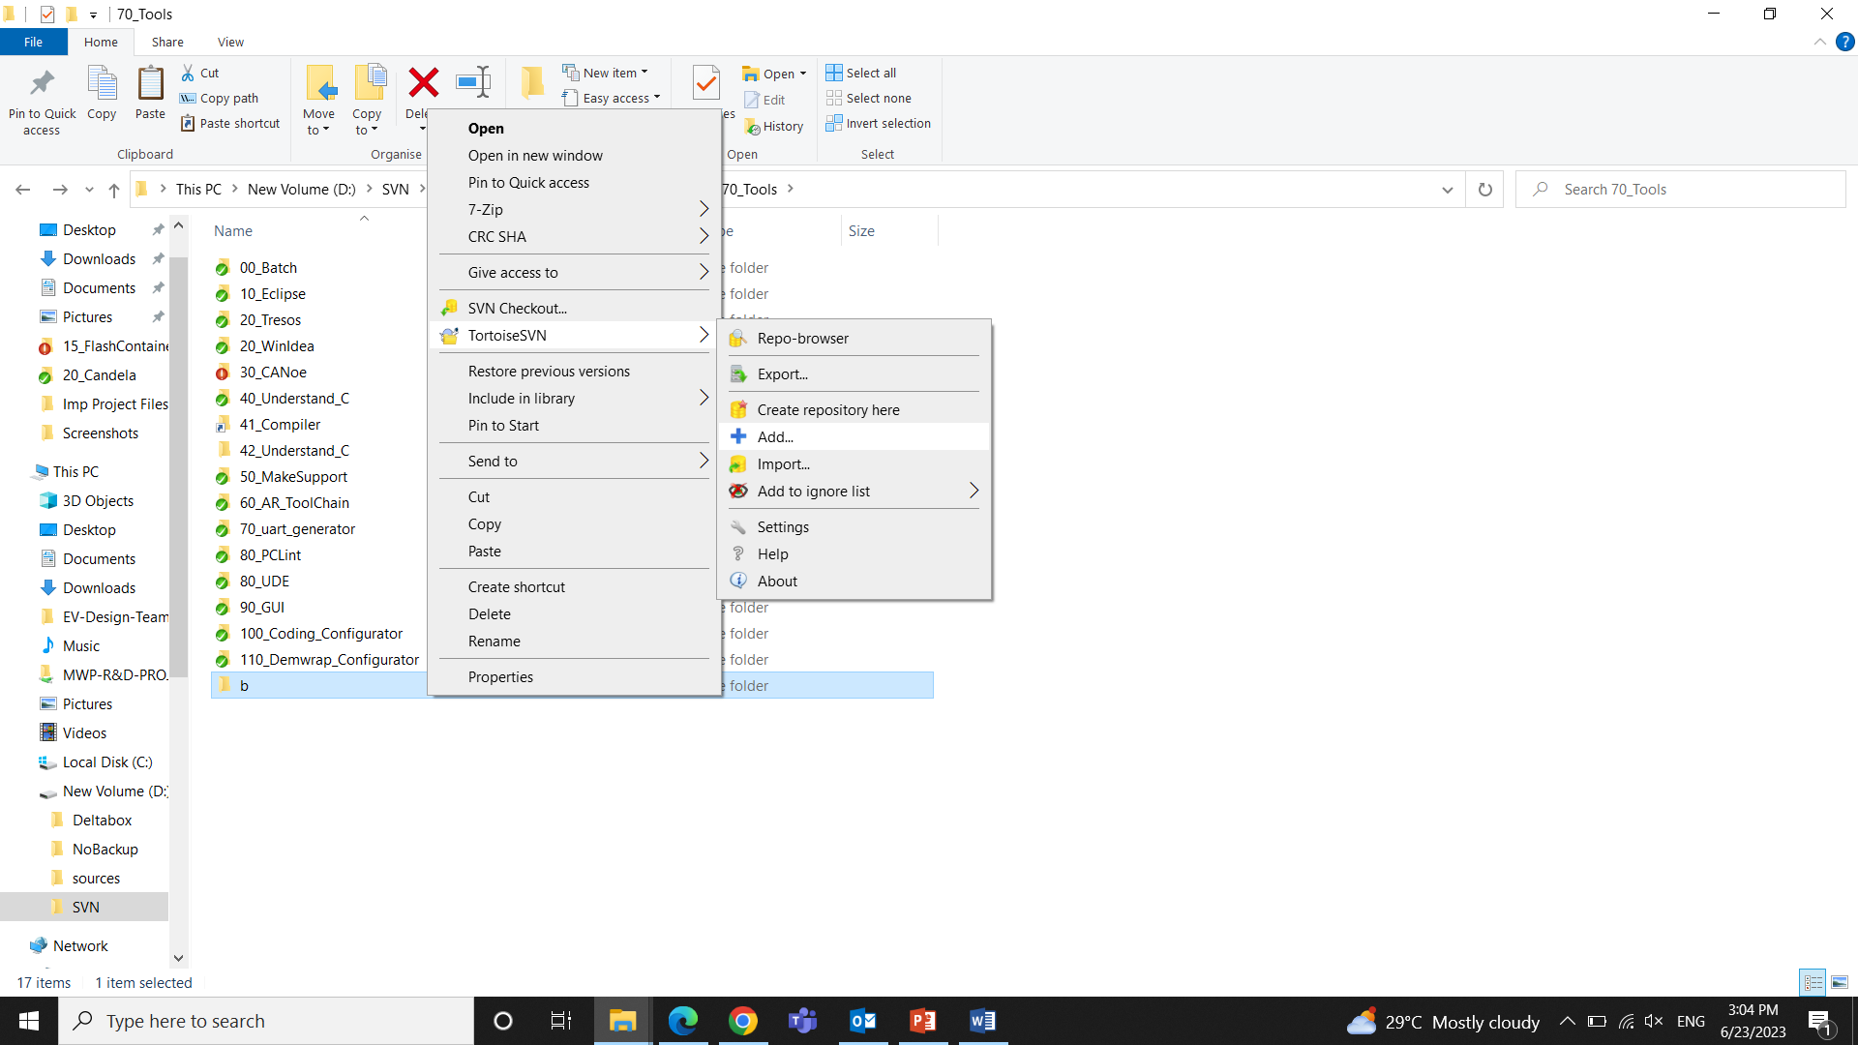

Diff

If we made any changes to a file and then **right click** to open SVN. It will show **diff** from where we can compare that file with previous revisions.

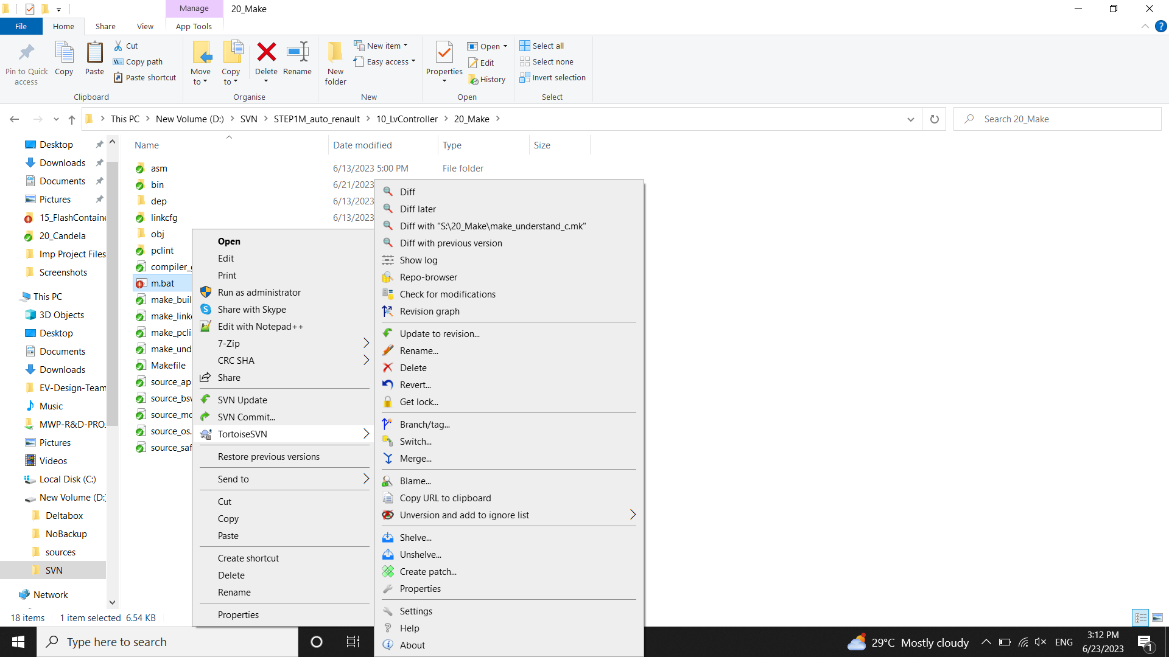

**CHAPTER 2**

# 2. Building , Flashing and Debugging

Building a file refers to compiling the Source file by linking all the object and linker files using the specified compiler. The process gives an executable file which can be flashed onto ECU.

## 2.1Building

We need to create S drive which is the copy of project files in D:\SVN\STEP1M_auto_renault\10_LvController

We will be making changes related to project in S drive which will be affected in D drive too.

Why to Create S drive?

In order to standardize the path of files as many developers are involved in the project. So we use a common drive S as many files involving stating the path.

Step 1: To Create S drive

D:\SVN\STEP1M_auto_renault\10_LvController\70_Tools\00_Batch

In this path open Batch file named 10_map_project

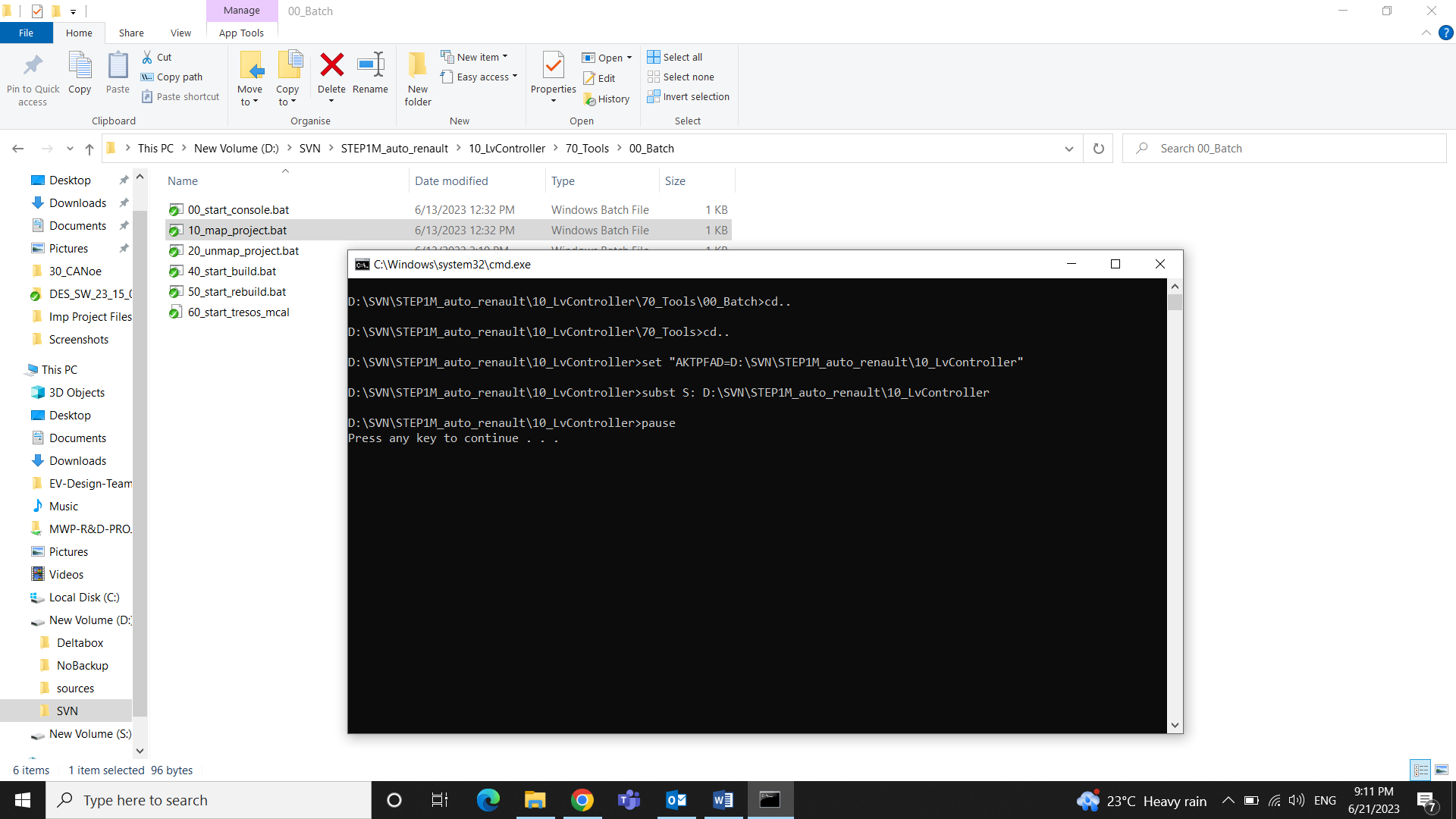

Step 2: S:\20_Make

In the above path open m.bat file using Notepad++ and add the username and path for the compiler.

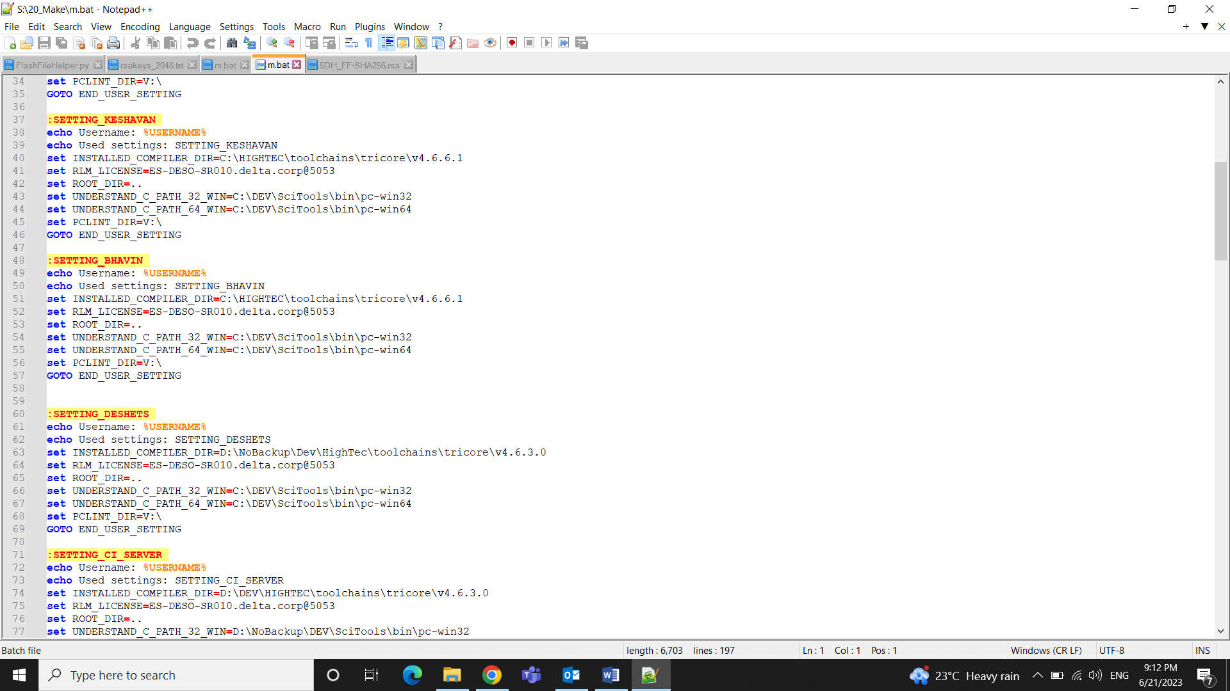

Step 3: Delete the current files (.elf , .hex, .map) from bin in the path S:\20_Make

Step 4: Type **cmd** in S:\20_Make to open the command prompt

Step 5: Type **m build** to do the incremental build, **m rebuild** to do complete fresh build

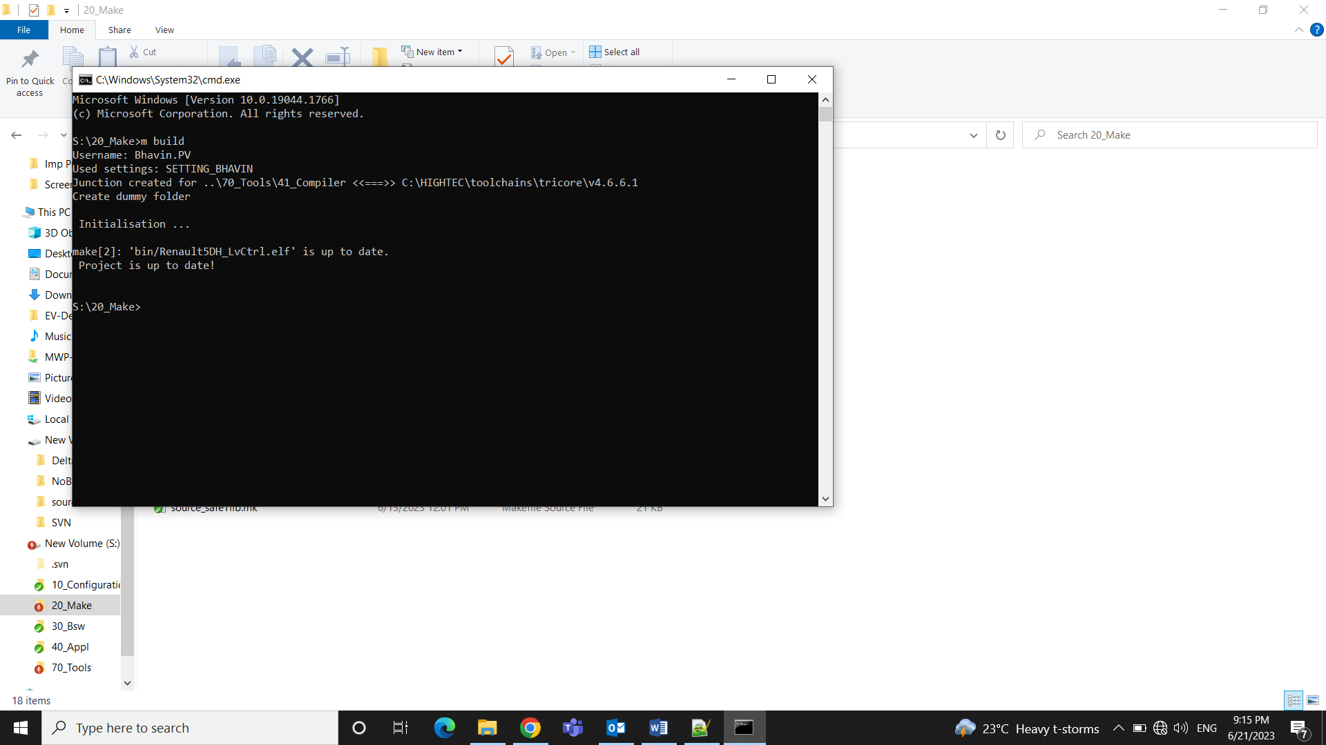

2.2 Flashing

Flashing code into an Electronic Control Unit (ECU) refers to the process of writing or updating the software that controls the functions and behavior of the ECU.

### 2.2.1 Flashing the Application

Connections:

Winidea Debugger is connected to ECU through JTAG and to computer through USB

CAN is connected to computer through USB and to ECU through connector.

Software used: Winidea debugger, CANoe tool

Step 1: S:\70_Tools\30_CANoe

In the above path open EXTCAN_5DH.cfg using CANoe

Step 2: In **Hardware** Open **Channel Mapping** in the CANoe Software

Check correct channel is mentioned in On Board CAN channel by confirming it from the CAN tool i.e. through which channel ECU is connected to CAN

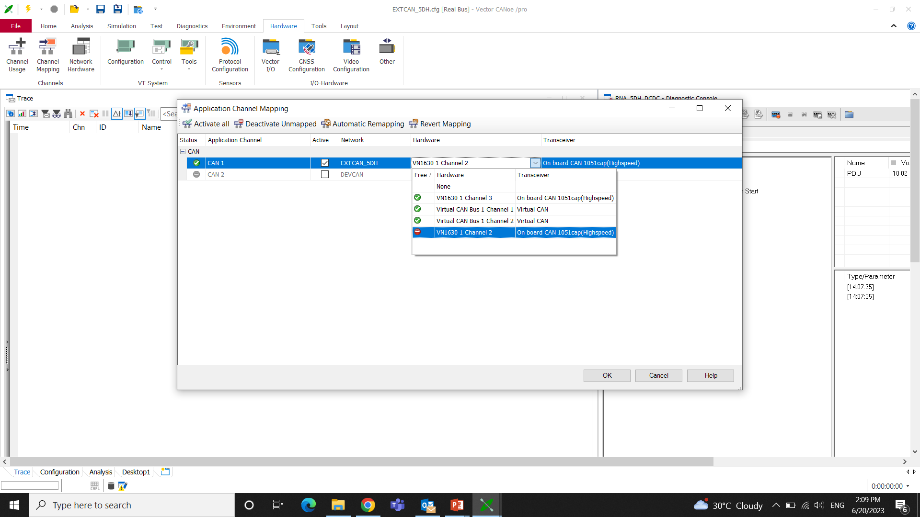

Step 3: S:\70_Tools\20_WinIdea

In the above path open LLC_AURIX.xjrf using Winidea software

Step 4: To check communication between ECU and debugger

In Windiea software select **Hardware** > **Debugger Hardware** **> Communication**>**Test**

It will show “**Communication OK** “if the communication is properly established between both ECU and debugger.

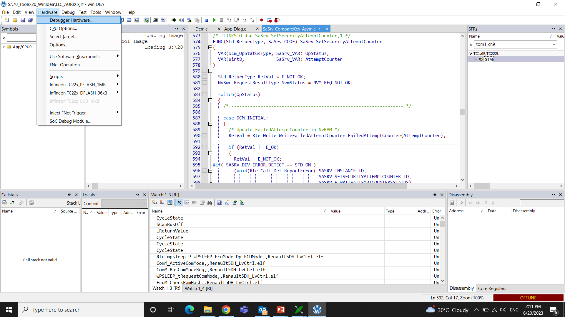

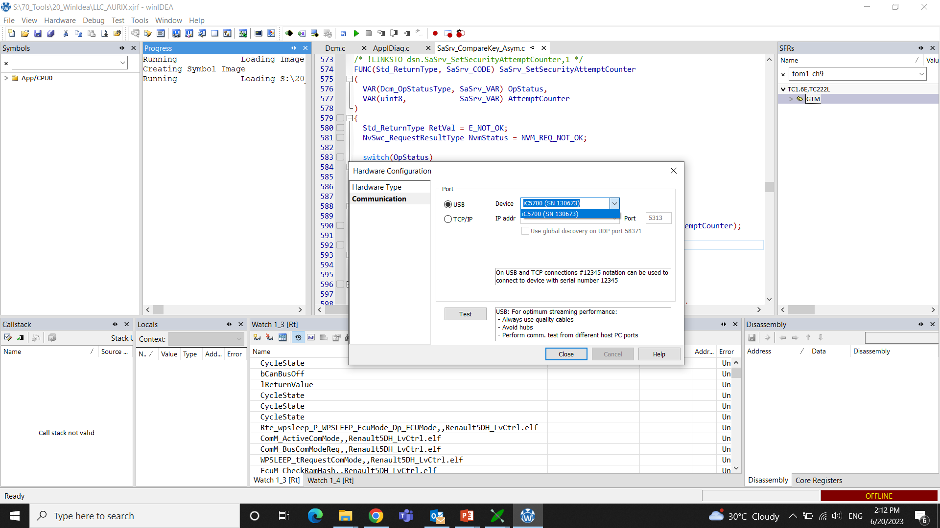

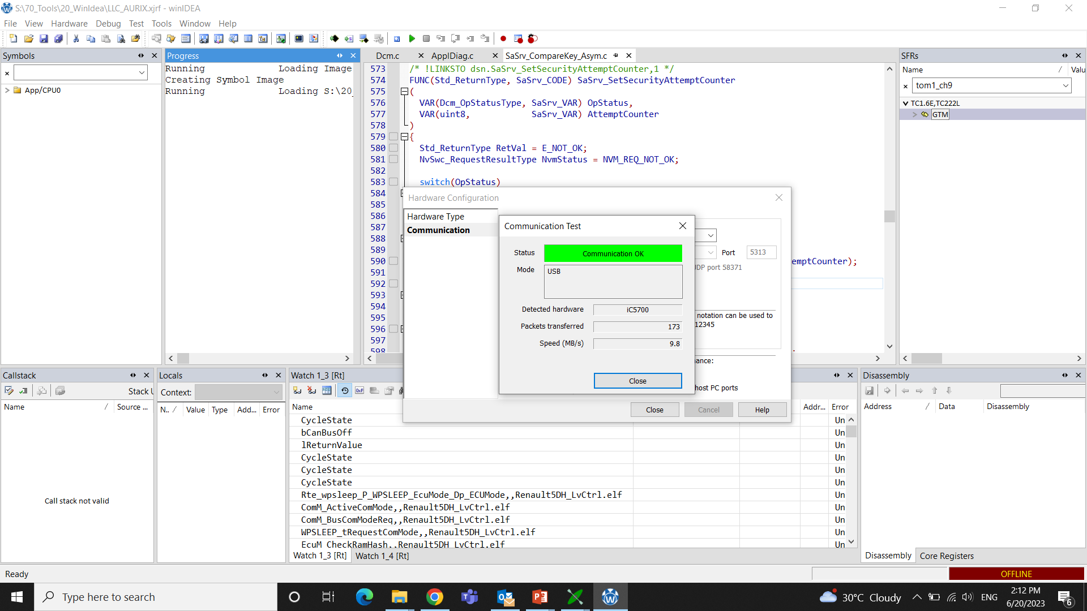

Step 5: In Winidea software select **Debug** > **Config Session** >**Wizard**

Add proper. elf file from S:\20_Make\bin

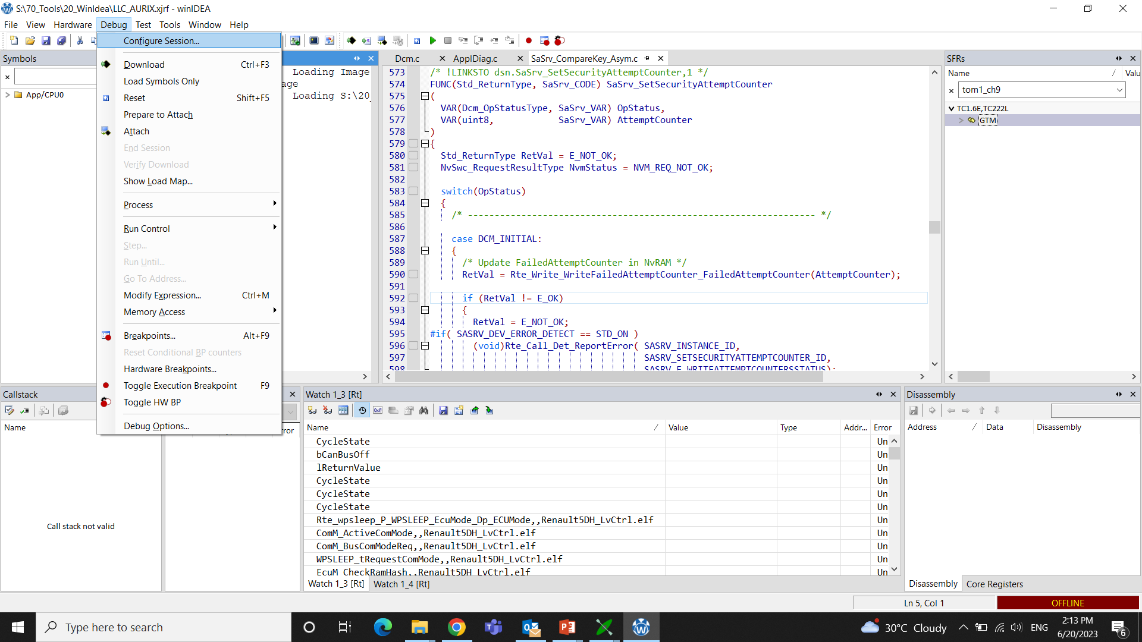

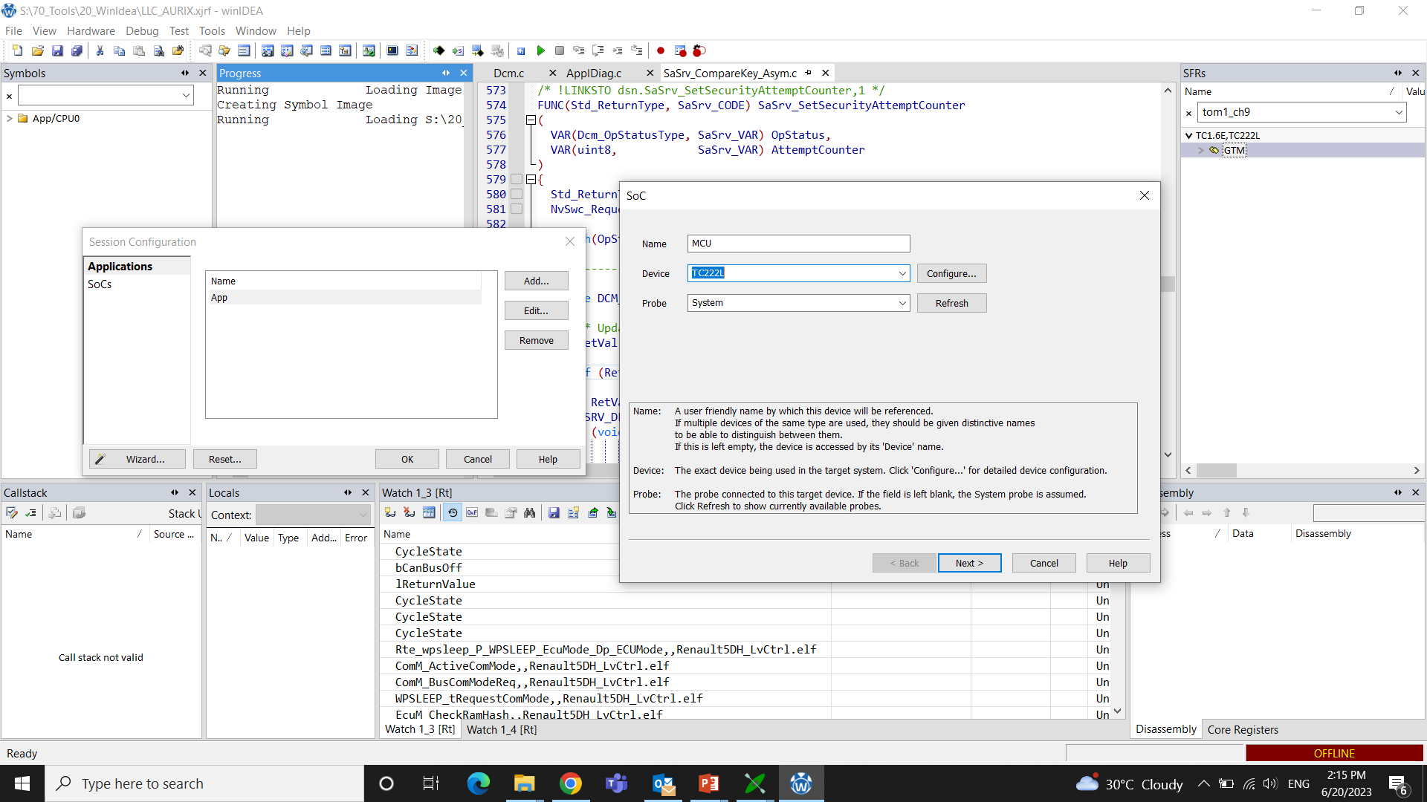

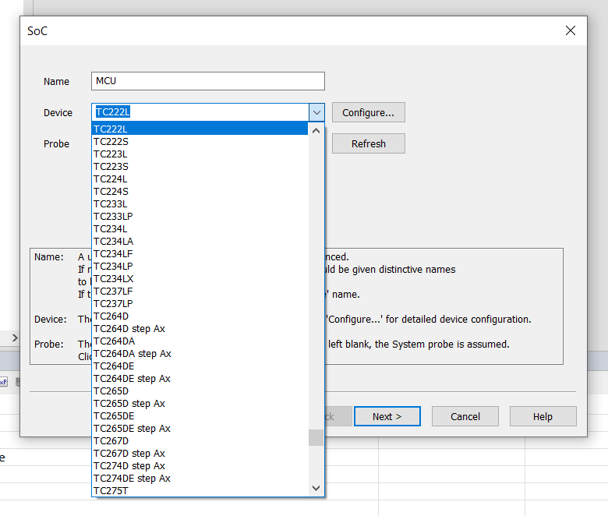

Also make sure that Correct Device is mentioned in the Device section. Here we are using **TC222L** SOC from Infineon. The Probe section is Mentioned as **System**.

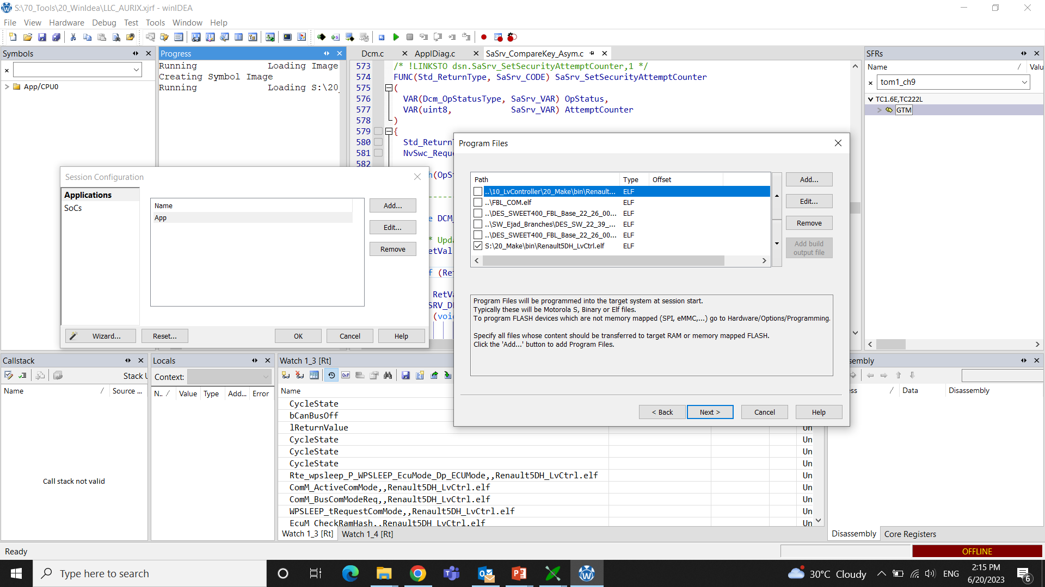

Step 6: In **Wizard** Select **Configure**

Reset, Debugging, Hardware, Analyzer, SoC advanced, SoC events, Cores Options are kept as Default

In **SoC** Option **Debug Channel Mode** is Kept as “**DAP WIDE**” and Clock Frequency as **10000Khz**

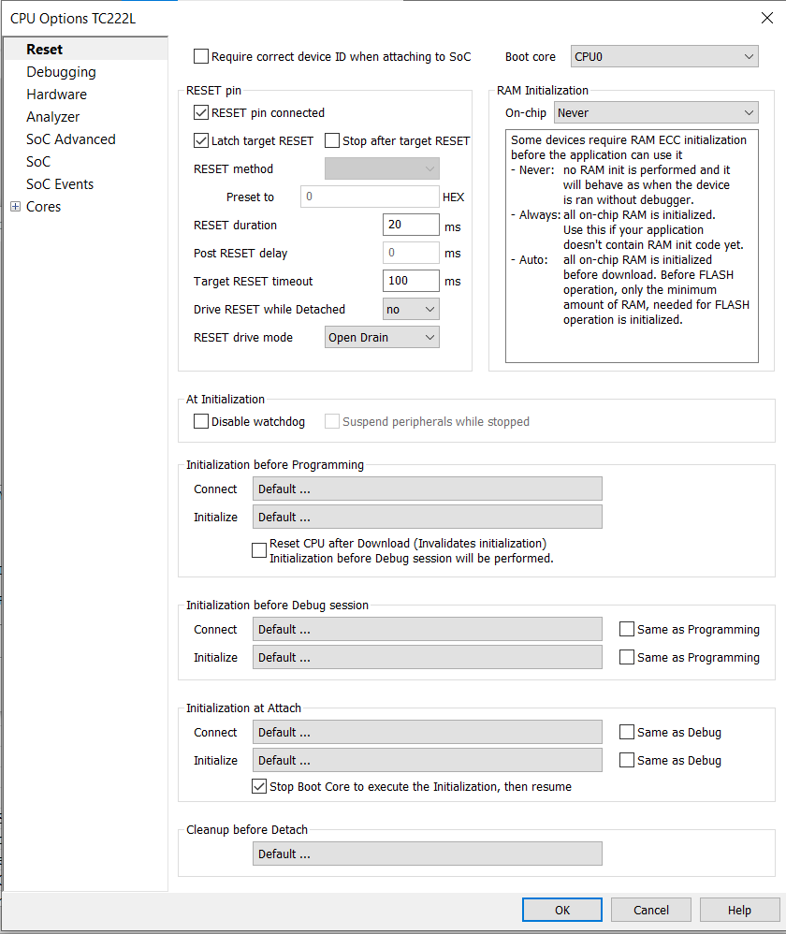

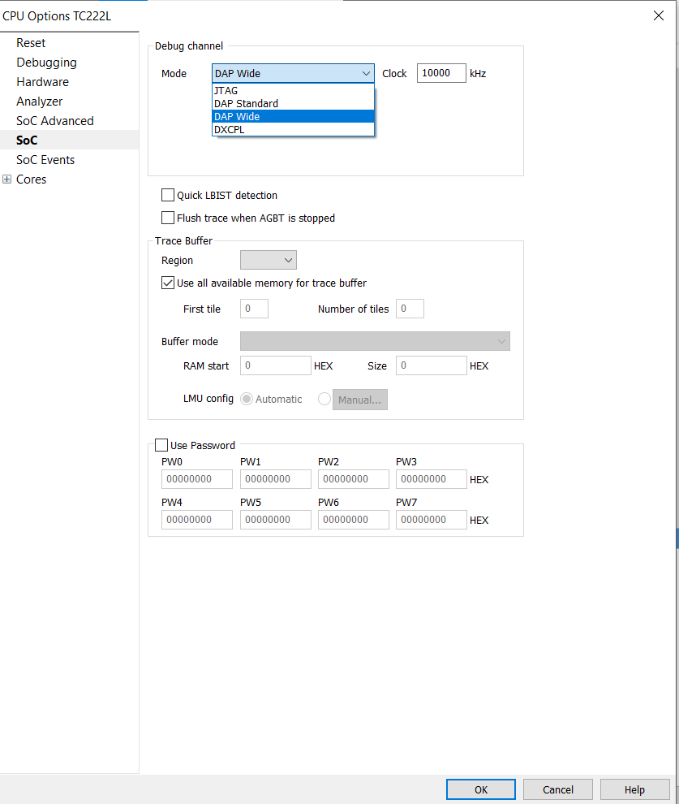

Step 7: In Winidea select **Download** and **Play**

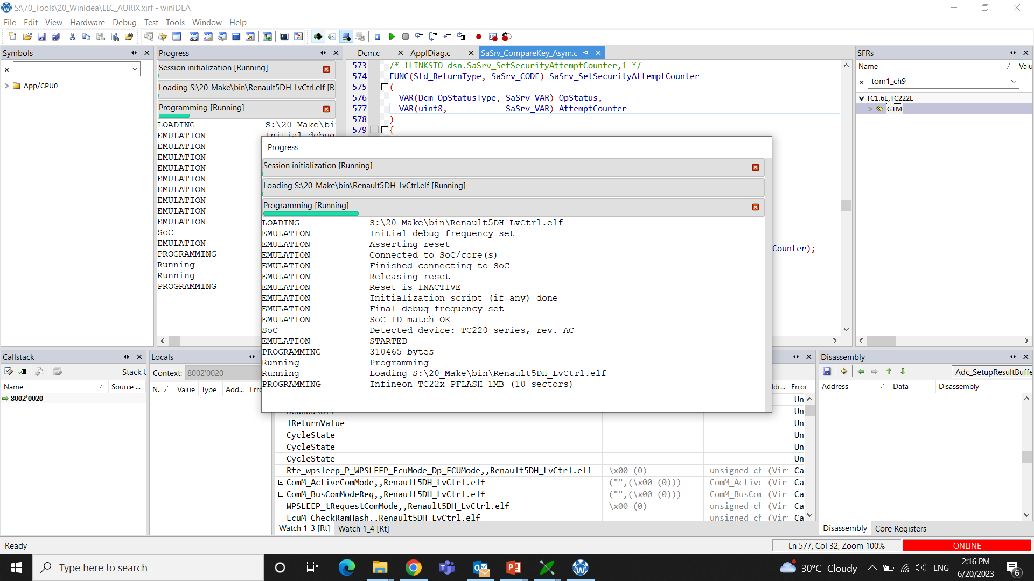

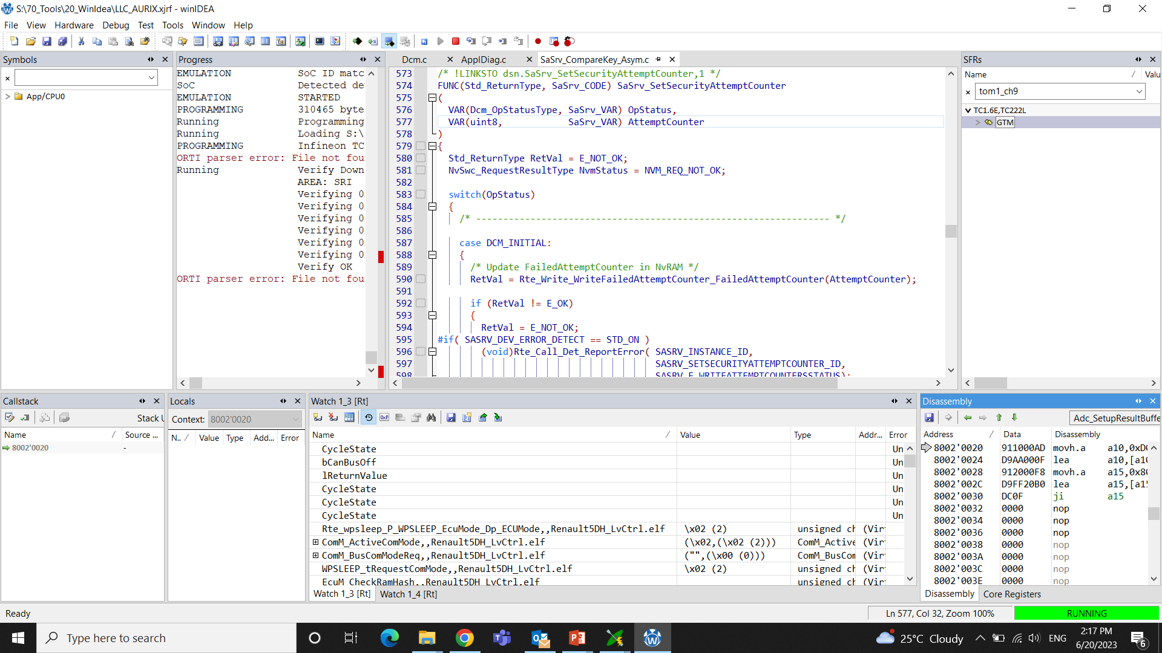

To add alive counter, that gives the state of variables

Copy the variable name and then paste it to the watch window.

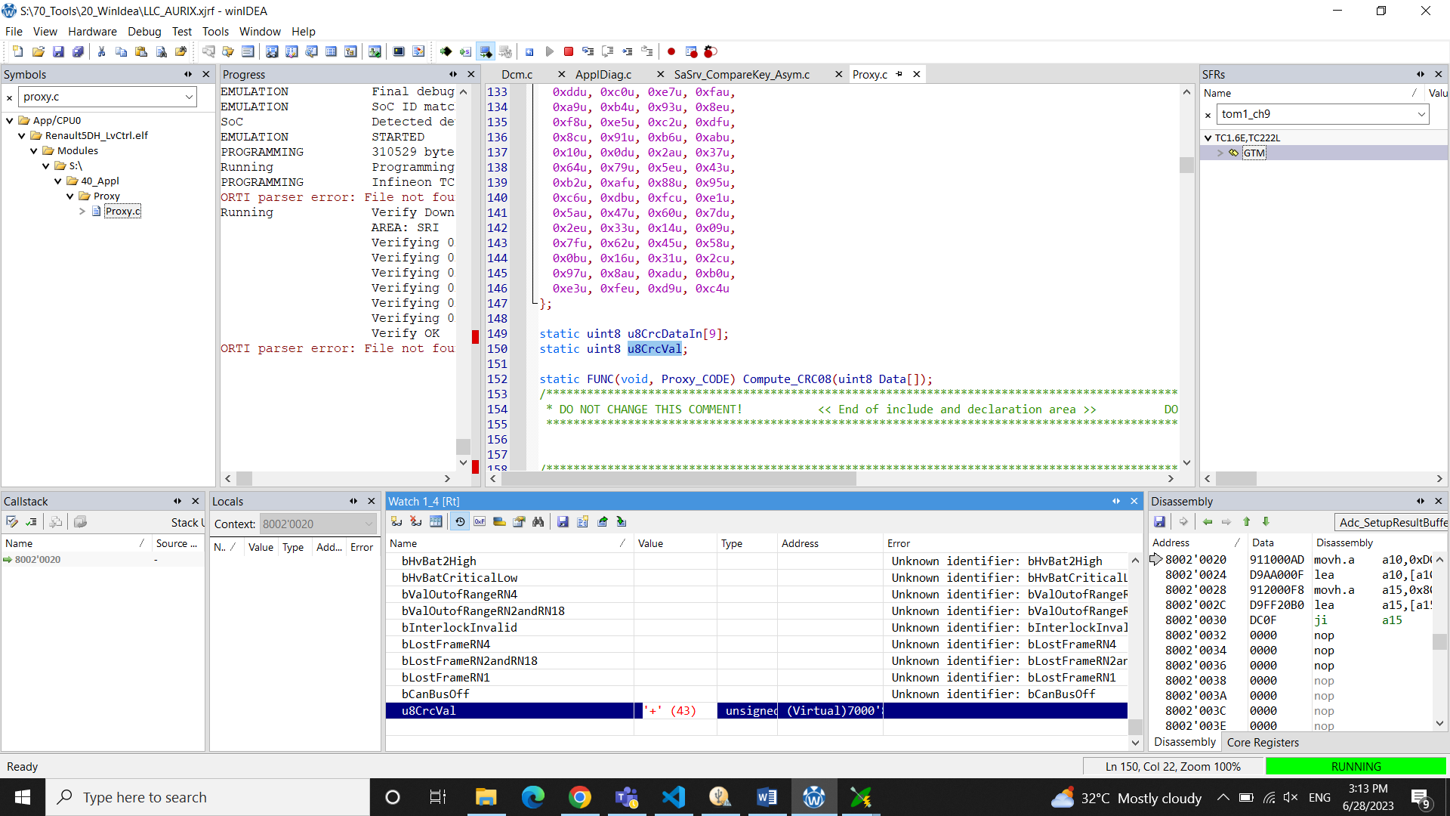

Here we need to watch a variable from Proxy.c file in 40_Appl

We can only monitor global variables in the watch window

Step 8: Select **Start** in CANoe

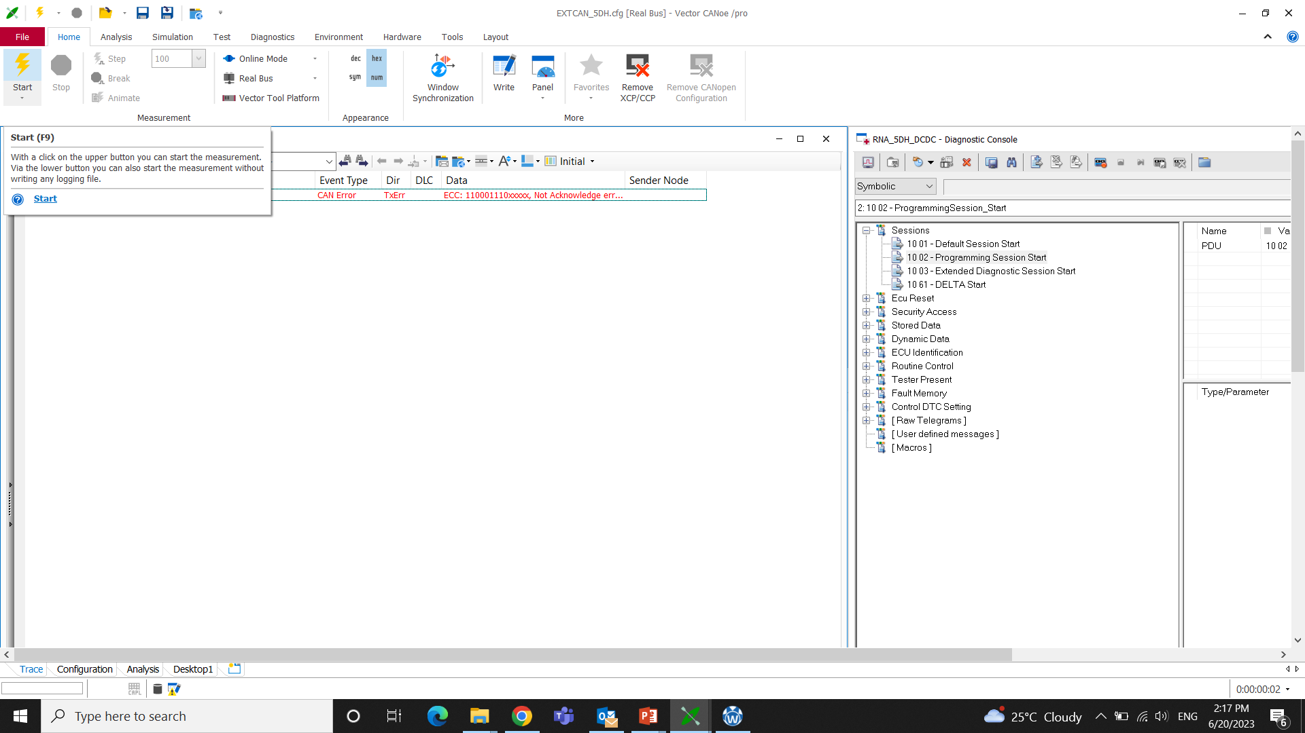

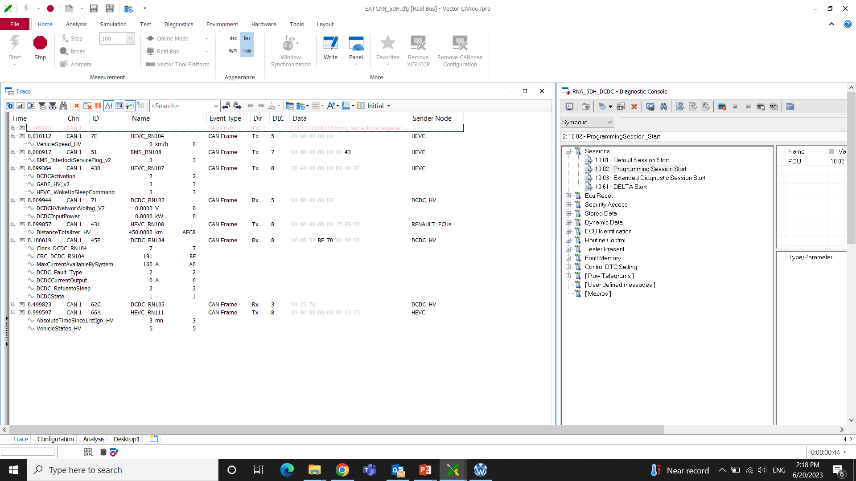

### START CANOE, FLASH IN WINIDEA ,POWER CYCLE.

### 2.2.2 Flashing the Bootloader

Connections:

Winidea Debugger is connected to ECU through JTAG and to computer through USB

CAN is connected to computer through USB and to ECU through connector.

Step 1**:** Repeat the steps as in flashing the Application from Step1 to Step 4

Step 2: In Winidea software select **Debug** > **Config Session** >**Wizard** Add proper. elf file from

D:\SVN\STEP1M_auto_renault\DES_SWEET400_FBL_Base_22_26_00\10_FBL_LV\20_Make named **FBL_COM.elf**

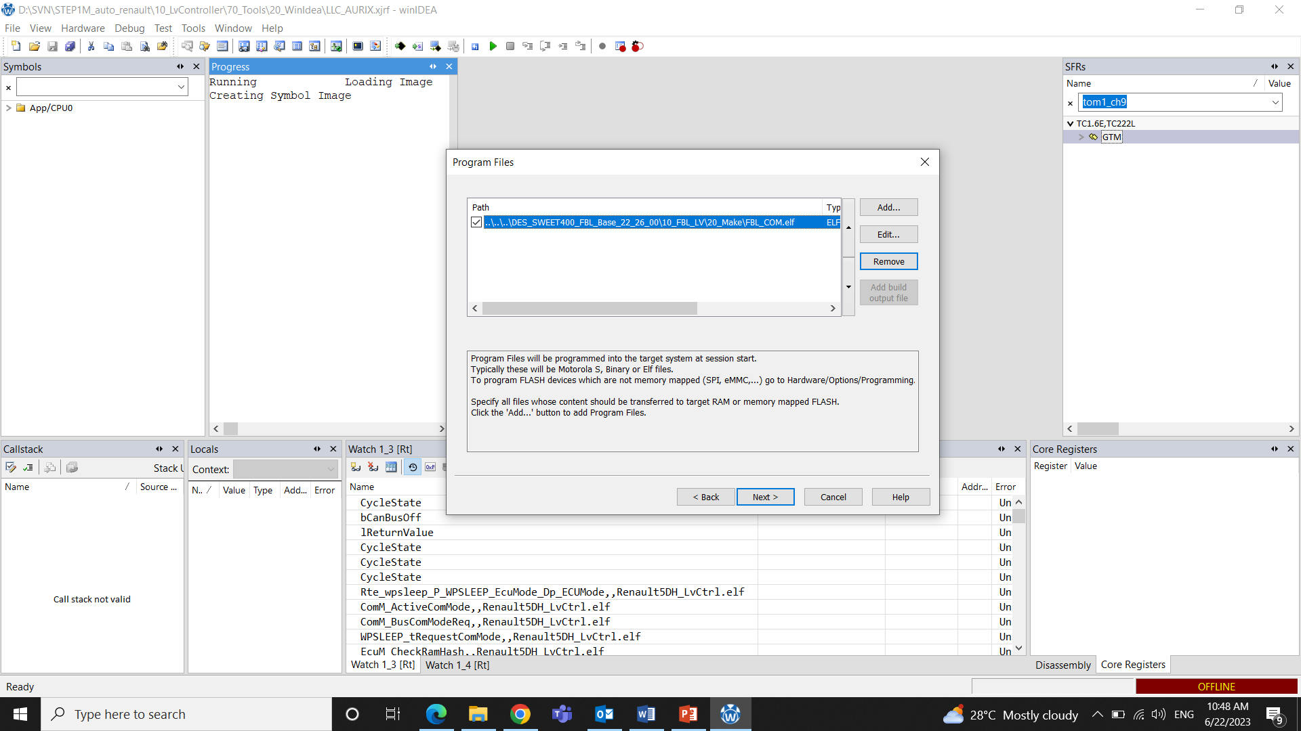

Step 3: Mass Erase both P and D flash so that the Soc is without any data

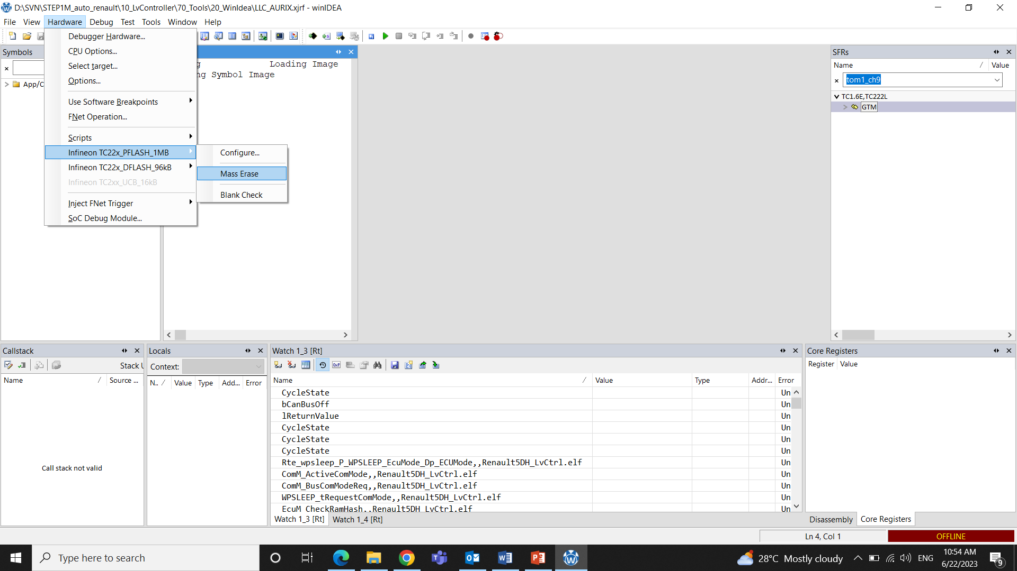

Step 4: In Winidea **Download** and **Play** . Open CANoe and **Start** to see the traces

**CHAPTER 3**

# 3.Release Folder

## 2.1 Introduction

What is a bootloader?

The bootloader in an ECU is a software component that facilitates the firmware update process for the ECU. It allows for the installation of new or updated firmware onto the ECU, which can include improved functionality, bug fixes, performance enhancements.

## 2.2 To create pdx

Step 1: D:\SVN\STEP1M_auto_renault\DES_SWEET400_FBL_Base_22_26_00\45_Appl_Tools\15_FlashContainer_DiagH

Open the folder 15_FlashContainer_DiagH

Step 2: Open **input** folder and Replace **Renault5DH_LvCtrl.hex** file with new updated .hex file from S:\20_Make\bin

Step 3: Go back to 15_FlashContainer_DiagH

Step 4: Double click generate.bat to generate the combined (LV and HV) hex file in flash_appl

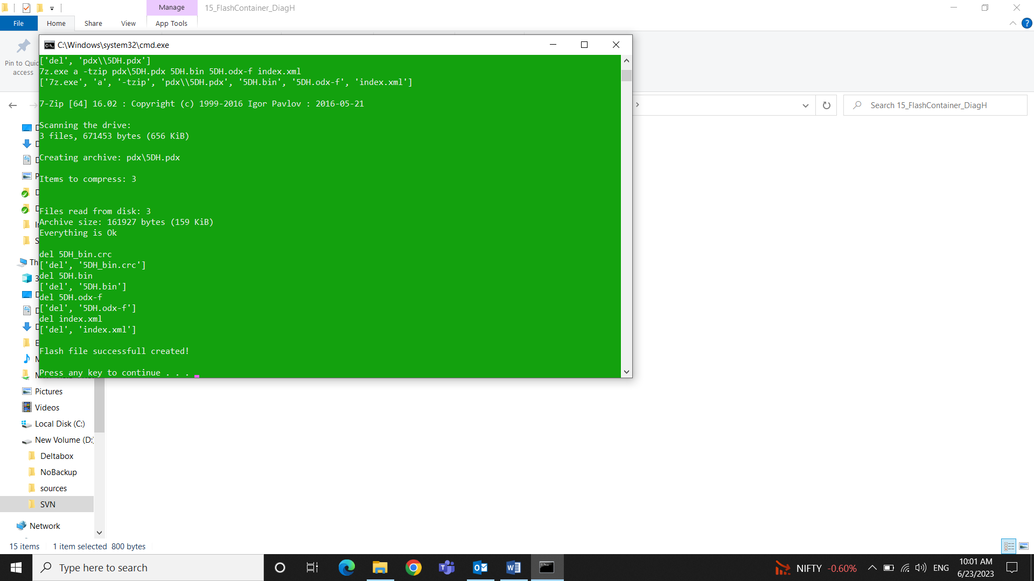

Step 5: Combined hex file with name **5DH_FF.hex** will be created in **flash_appl** folder of **15_FlashContainer_DiagH**. Copy this file and paste it into **15_FlashContainer_DiagH**.

Step 6: Drag and drop **5DH_FF.hex** into **_generate_SHA_DemoKeys.bat** to obtain the newly generated 5DH_FF-SHA1.crc and 5DH_FF-SHA256.rsa files

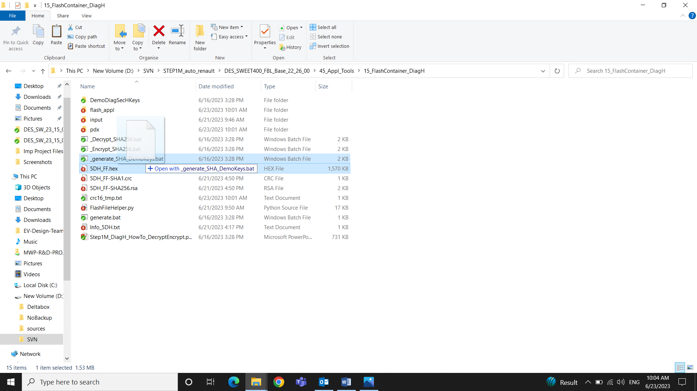

Step 7: To create pdx

Open the **5DH_FF-SHA256.rsa** file with notepad++ and make note of 256-byte key. Remove ***,0x*** part and the full 256-byte hex key is copied.

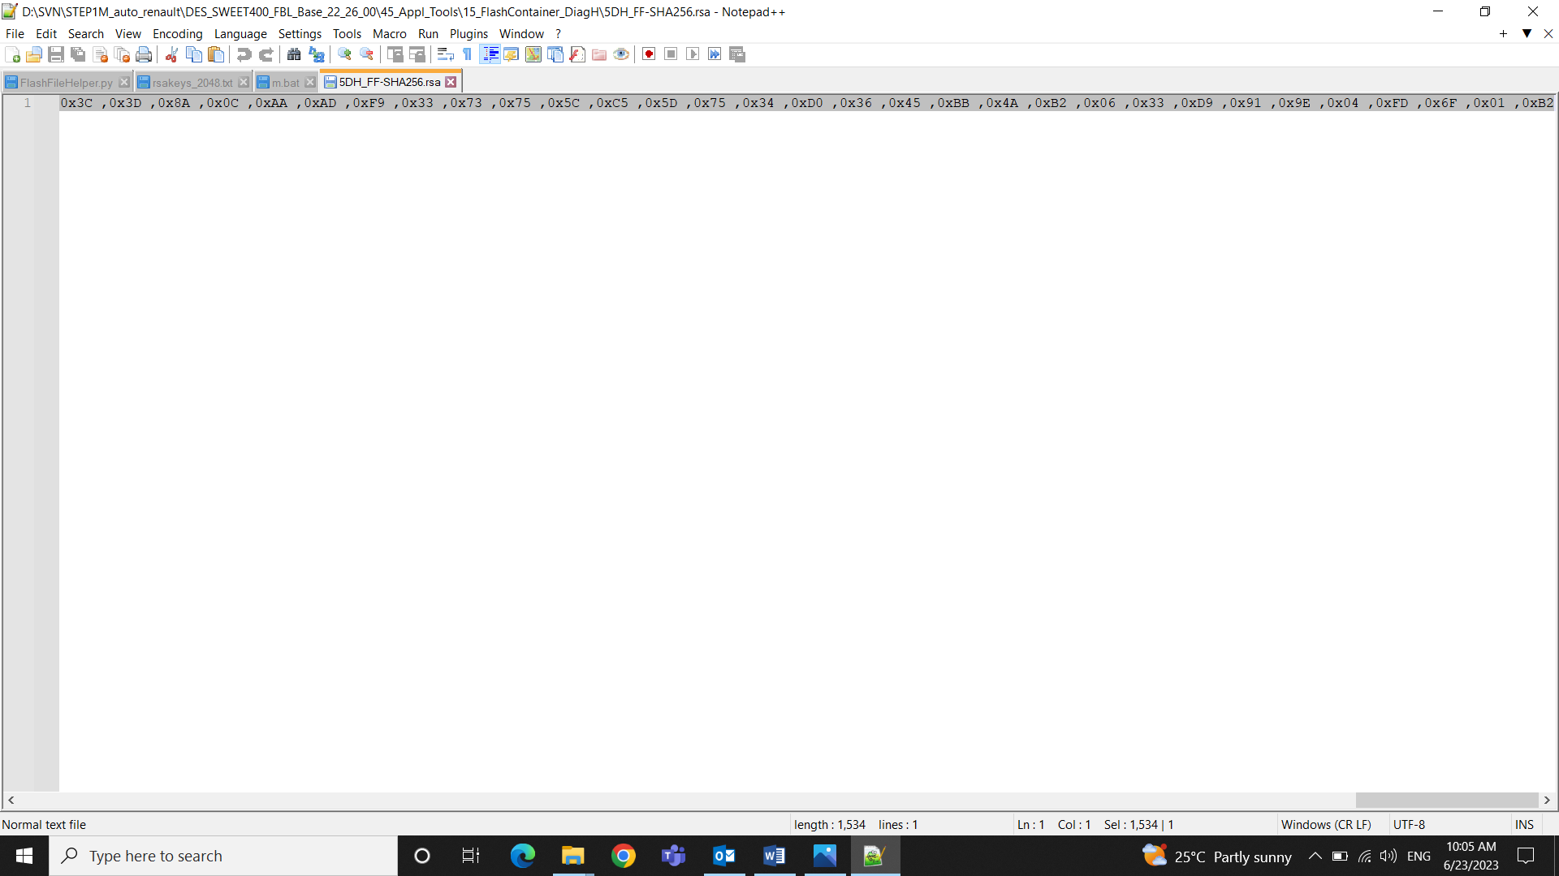

Step 8: The Copied key is pasted into line no. **222** of **FlashFileHelper.py** which can be opened using Visual Studio and save the file

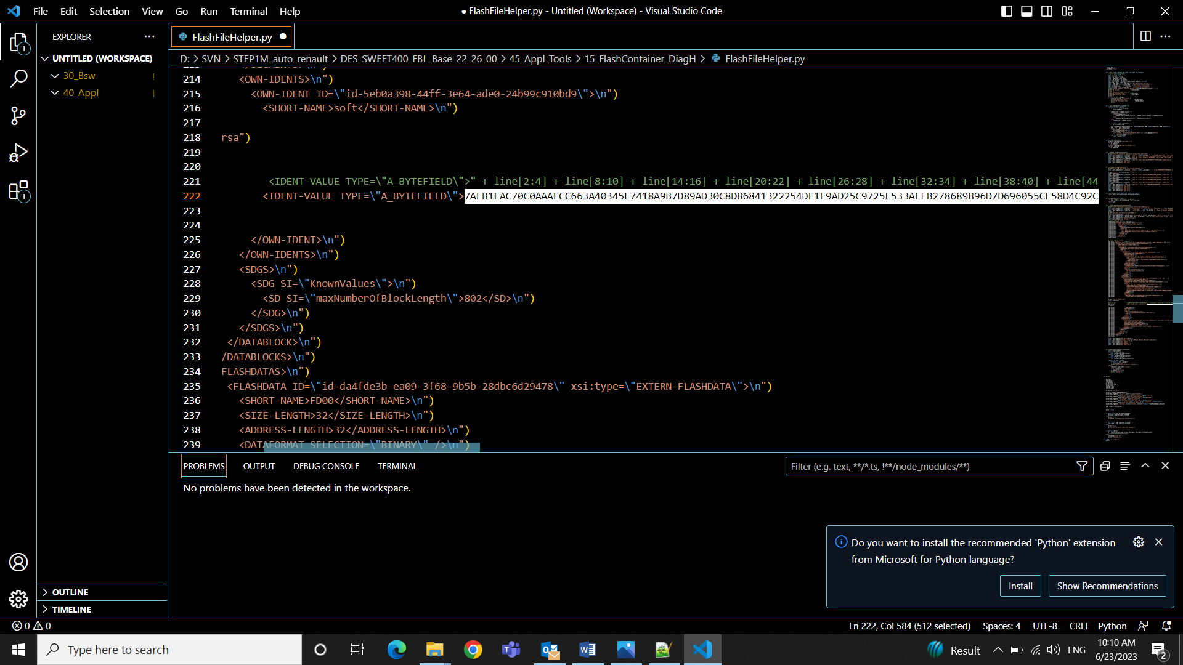

Step 9: Double click on generate.bat to create the pdx file.

**Note:**

Here most part of digital signing is taken care by HEX view software, which is internally called in the generate SHA file. We just need to update the RSA key into helper file and generate the pdx.

Here we are using generate bat file 2 times as the script for creating combined hex file and pdx file is in the same generate bat file. So when we generate combined hex file the script continues to produce a pdx file also which is not the actual updated one with new Sign.

## 2.3 vflashpack

Vflashpack is given to testing team or customer to flash the code onto ECU.

Step 1: Open any of the previous release folder say D:\SVN\STEP1M_auto_renault\230701_Internal_Release\DES_SW_23_15_05

Step 2: Open DES_SW_23_15_05.vflashpack using vector vflash software.

Step 3: Select **configure** and add the data block as hex file **5DH_FF.hex** and add Signature RSA file.

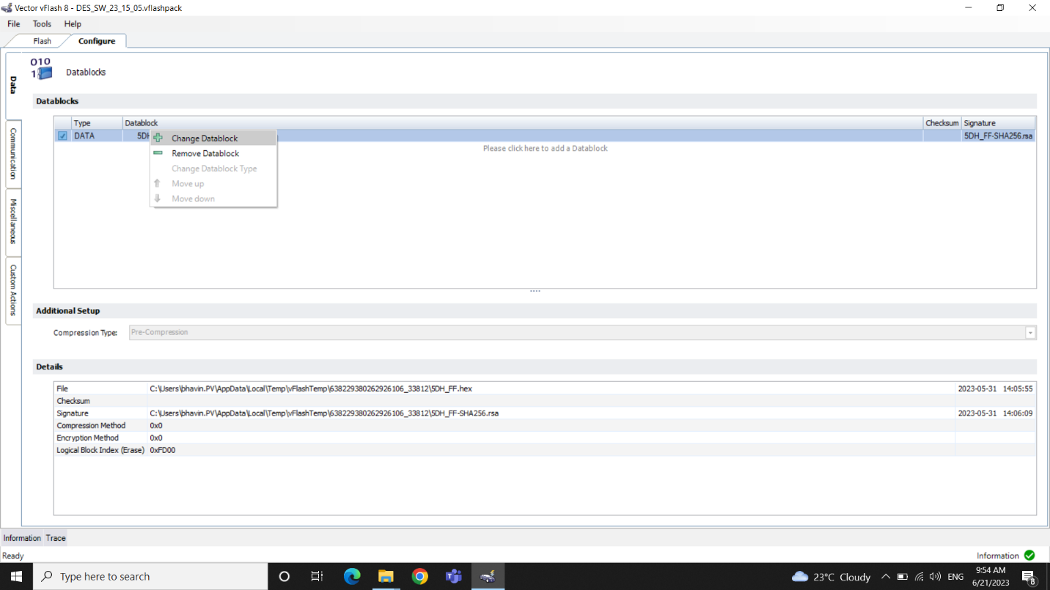

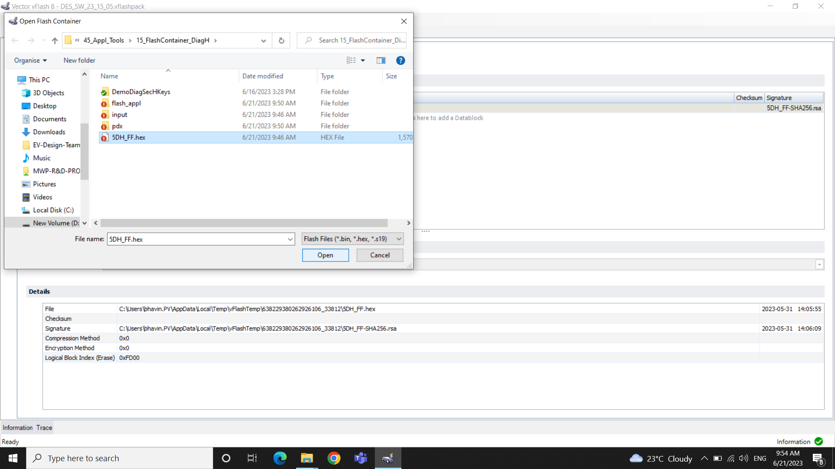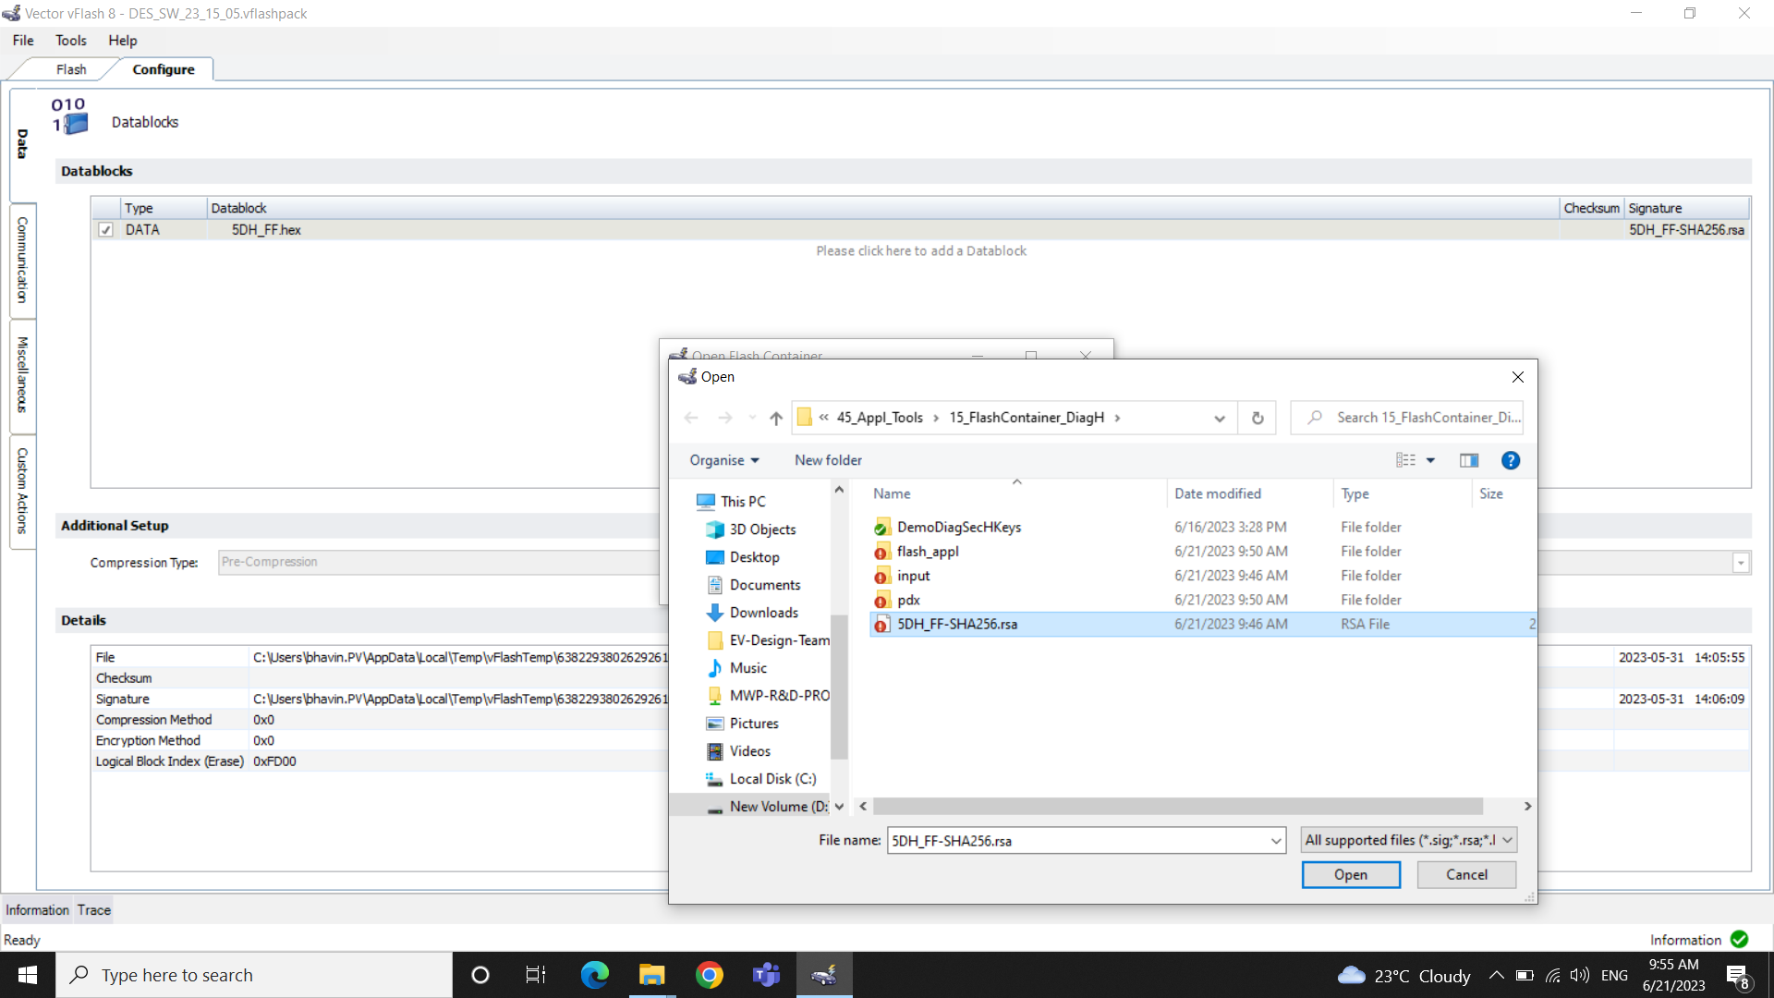

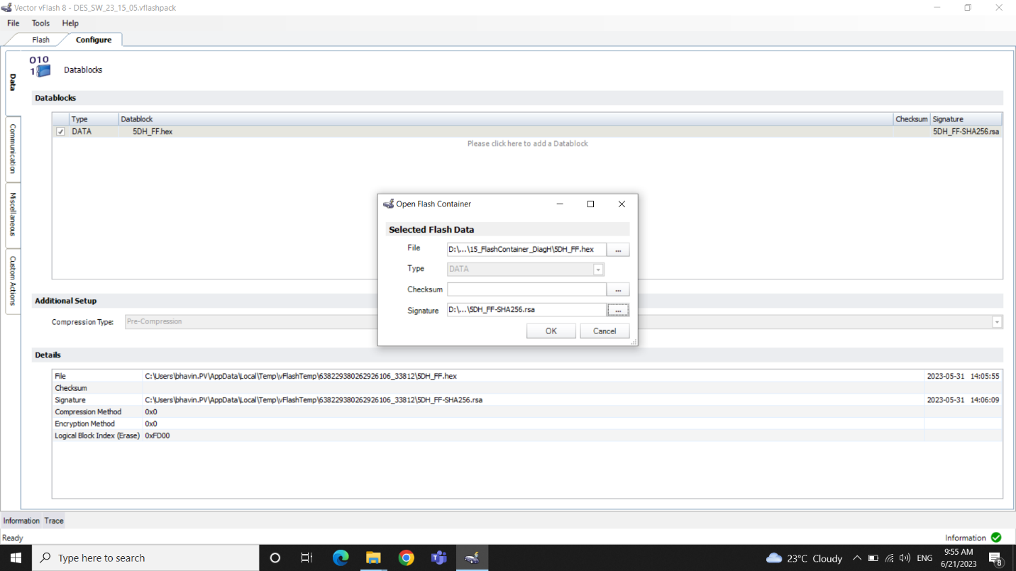

Step 4: Make sure that the logical block index is 0XFD00

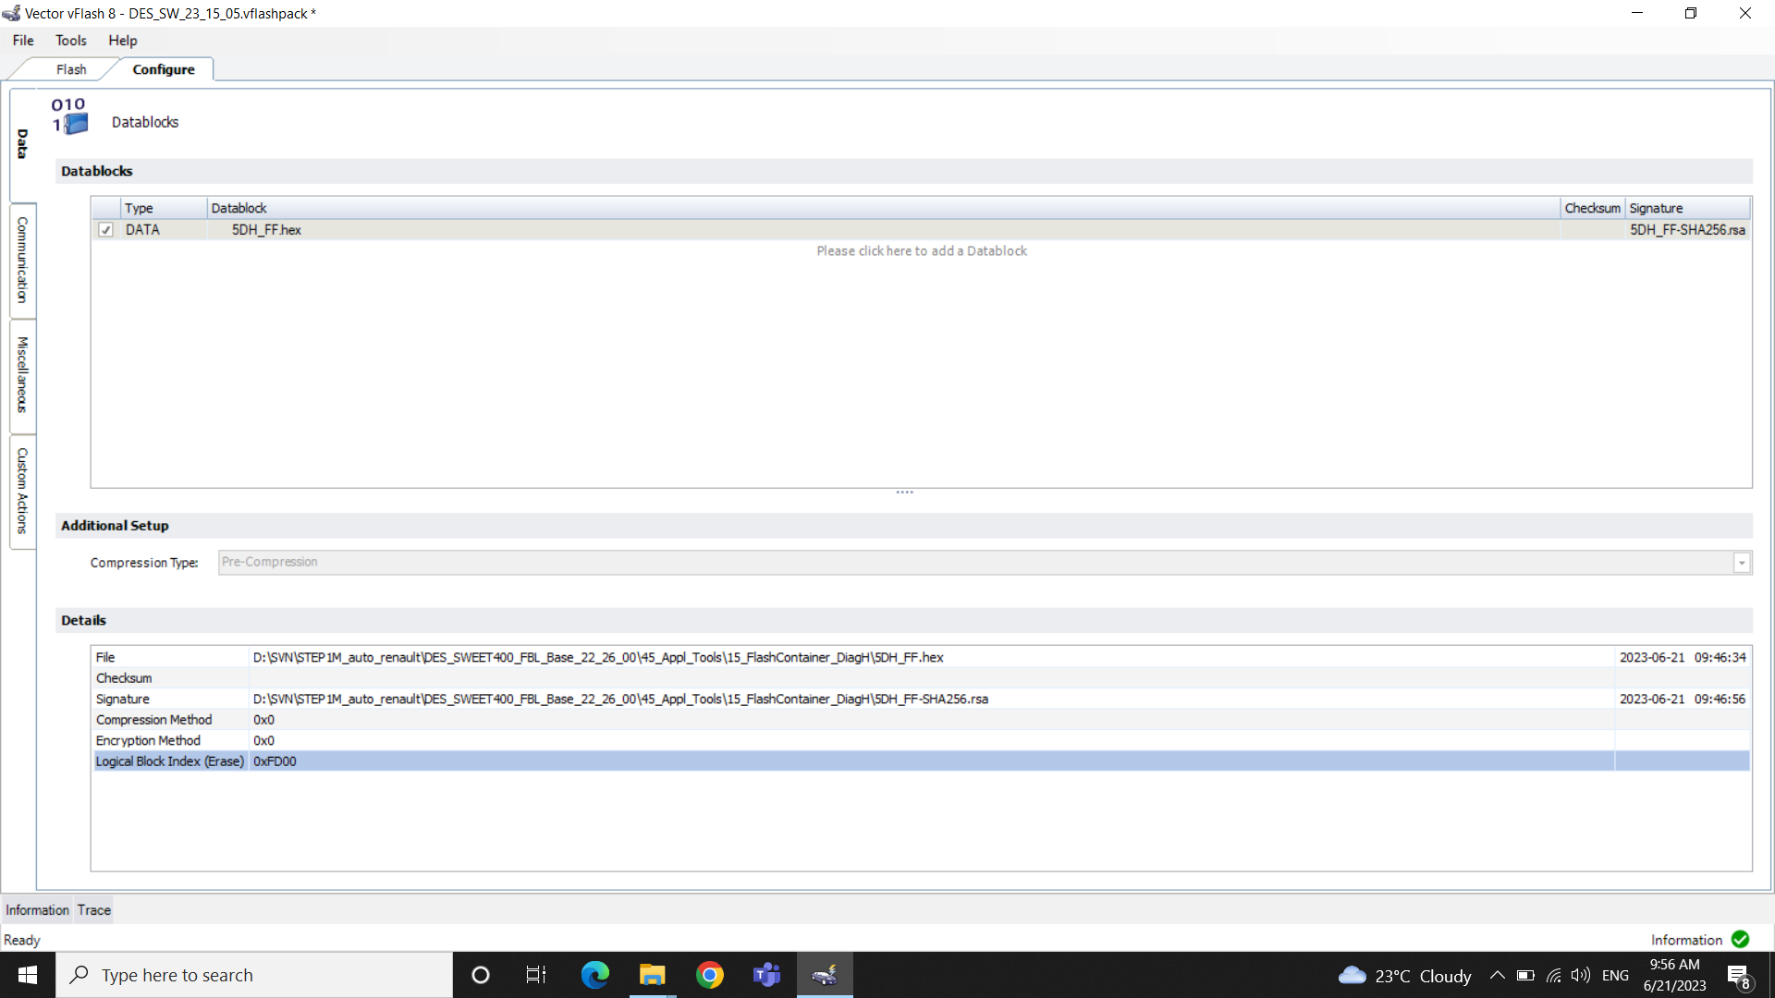

Step 5**: File** > **Export to pack and go** > Rename the file according to release > **Yes**

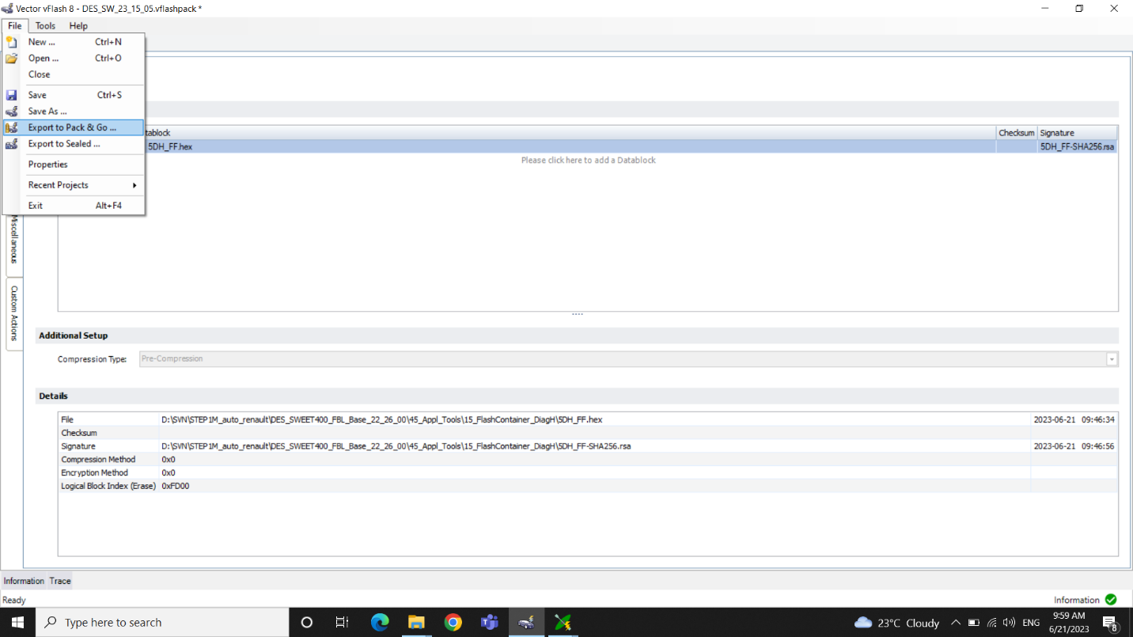

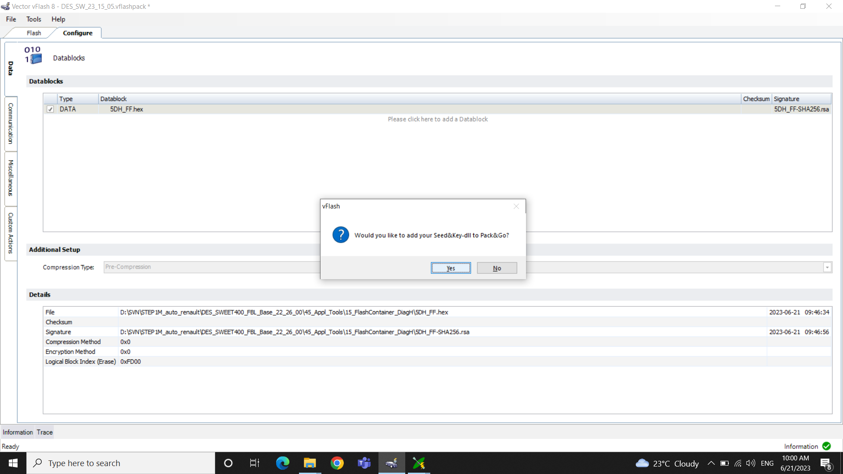

Step 6: Copy paste the new vflashpack file into the new release folder

## 2.4 Flashing the application using vflashpack

Step 1: Open the vflashpack file needed to flash

Step 2: Make sure that CAN Channel mapped is correct

Step 3: Select Flash

## 2.5 Release

Step 1: Create new Release folder with new software version name (Year, Week, patch) in D:\SVN\STEP1M_auto_renault\230701_Internal_Release.

Step 2: Add the following updated files into the folder

.vflashpack file

.pdx file

.cdd file

.dbc file

.rsa

.crc file

.hex file (5DH_FF.hex)

Update the file names according to the release versions.

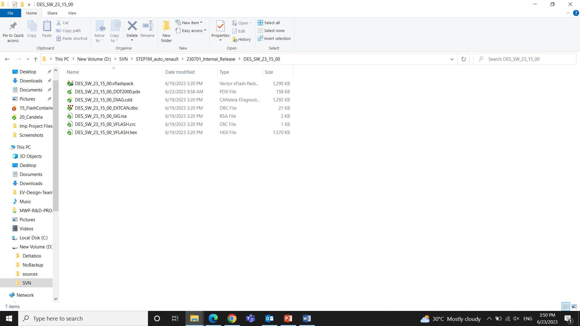

Step 3: Add the new Release folder into the Repository and then Commit.

On Doing a release we have to add the application files for LV, HV, FBL in the tags of Repo Browser.

And the release folder will be created in Trunk of Repo Browser.

**CHAPTER 4**

# 4. dbc and cdd file

The dbc and cdd files are input to DaVinci Configurator

## 4.1 Vector CANdb++ Editor

The CANdb++ Editor allows users to define the structure of the CAN communication network, including the definition of CAN messages, signal descriptions, and network nodes. It also supports the import and export of databases in various formats.

**Features**

1)Database Creation: Create new CAN databases from scratch or import existing databases from other formats such as DBC (CANdb), XML, or ARXML.

2) Message and Signal Definition: To define CAN messages, including their identifiers, frame types, and associated signals.

Signal definitions such as the signal name, start bit, length, scaling, and value types.

3) Node Configuration: To configure network nodes, including their node names, communication parameters, and the messages they send or receive.

4)Signal Multiplexing: Multiple signals to be transmitted within a single CAN message.

5)Database Validation: Ensure correctness of the database, such as checking for duplicate signal or message names, invalid signal definitions, or incomplete node configurations.

## 4.2 DBC File

DBC (CANdb) file format is used for defining and describing CAN (Controller Area Network) communication networks. DBC stands for "CANdb" (Controller Area Network database).

DBC files contain information about the messages, signals, nodes, and other elements of a CAN network.

Vector CANdb++ Editor is used to Create and Edit DBC files

Open EXTCAN_5DH_mockup.dbc from D:\SVN\STEP1M_auto_renault\10_LvController\10_Configuration\50_EXTCAN file path.

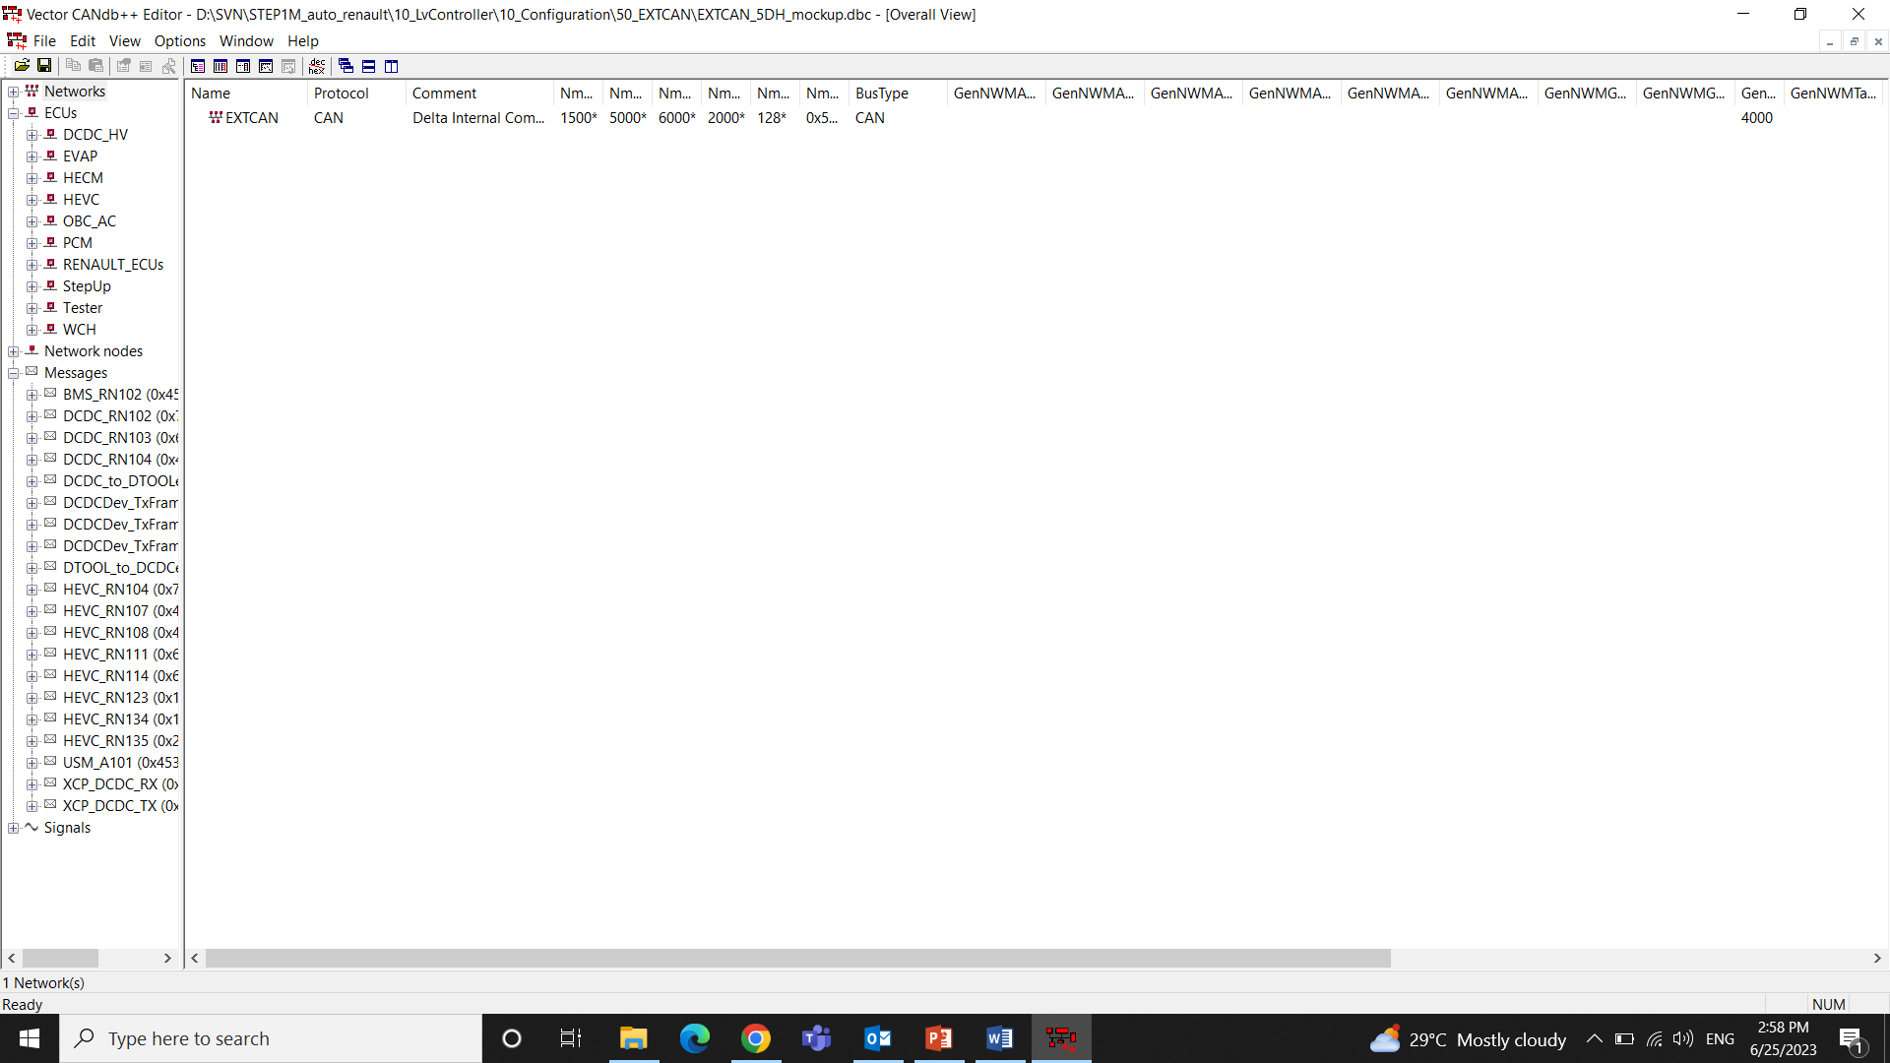

An Overview can be seen on opening the File. It includes Networks, ECUs, Network Nodes, Messages and Signals.

On Selecting each component in the left side window we can see the attributes related to it.

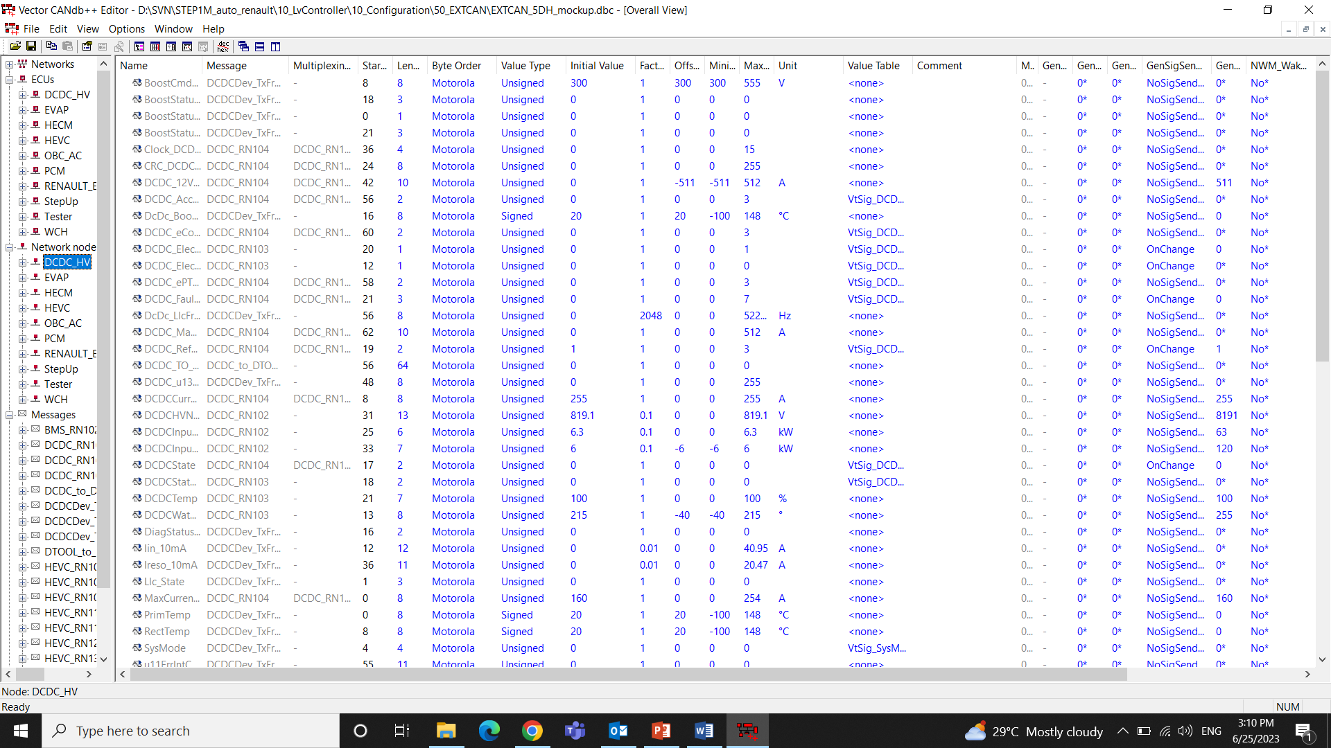

Here we can see all the signals associated with Network node DCDC_HV which is an ECU in the CAN Bus

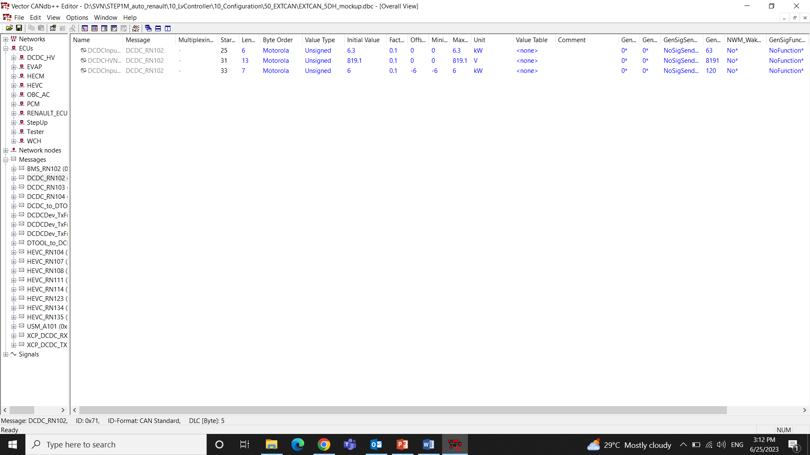

Here we can see all the signals associated with the CAN Frame i.e. a Message

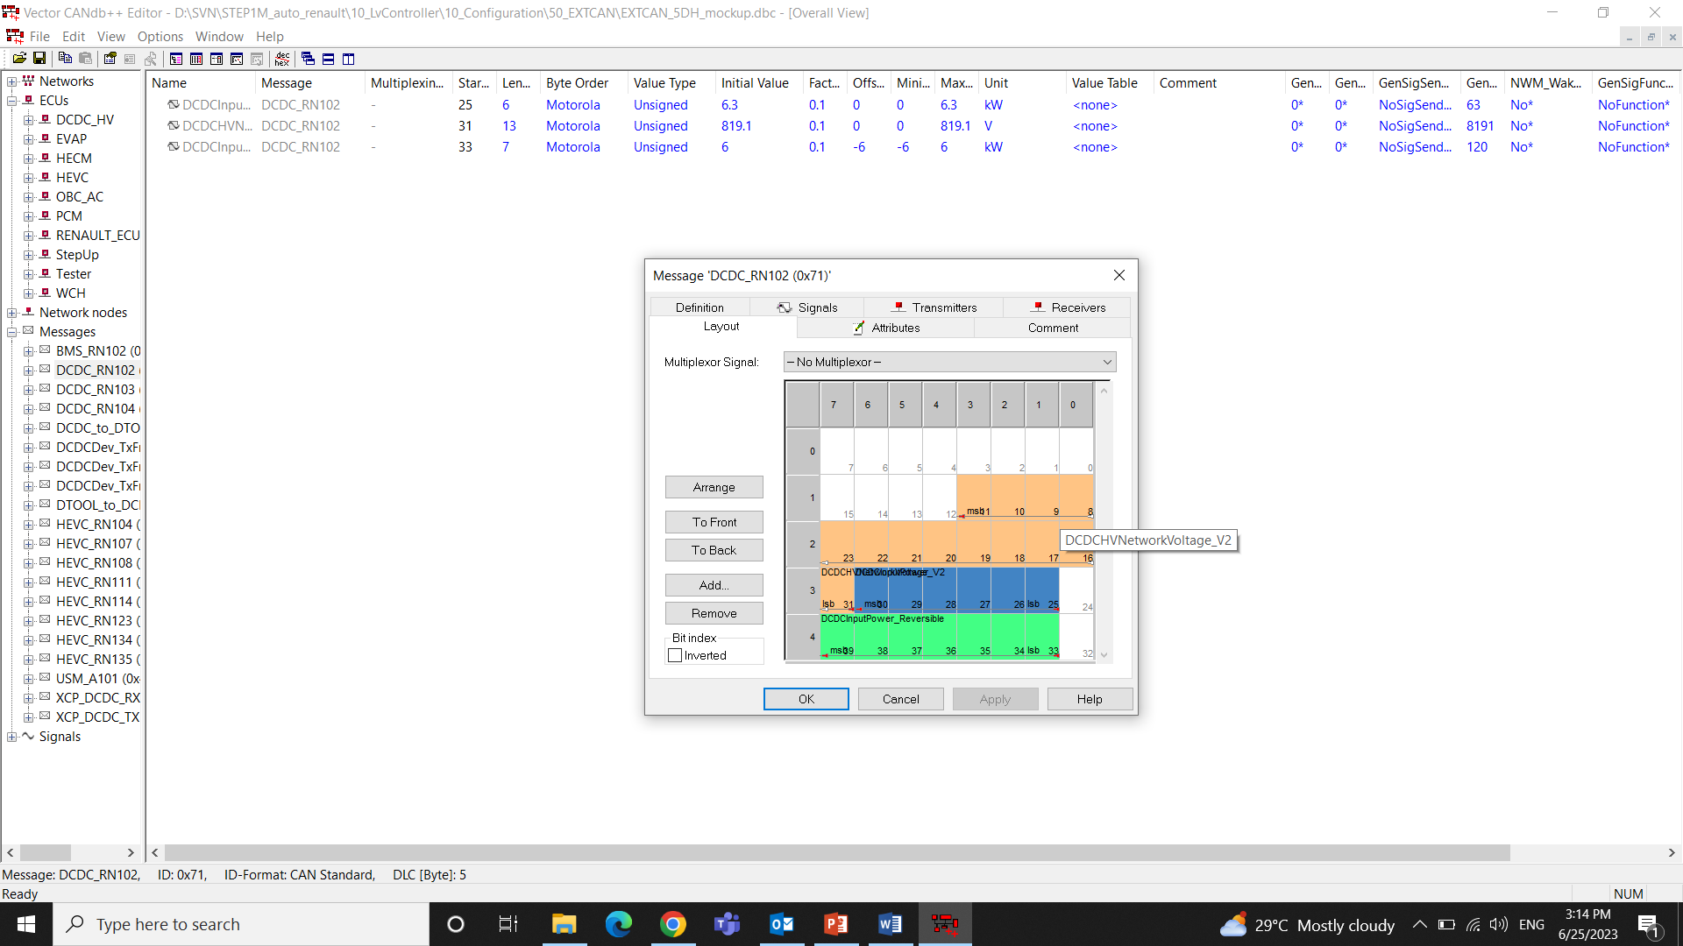

We can even see the Message layout with the positioning of signals in the Frame, start bit, Signal Length, Nodes which transmit the message and the node that receive it.

Byte Order Motorola represents it is written right to left (<-) in the CAN frame and Intel represents it is written from left to right (->) in the CAN frame.

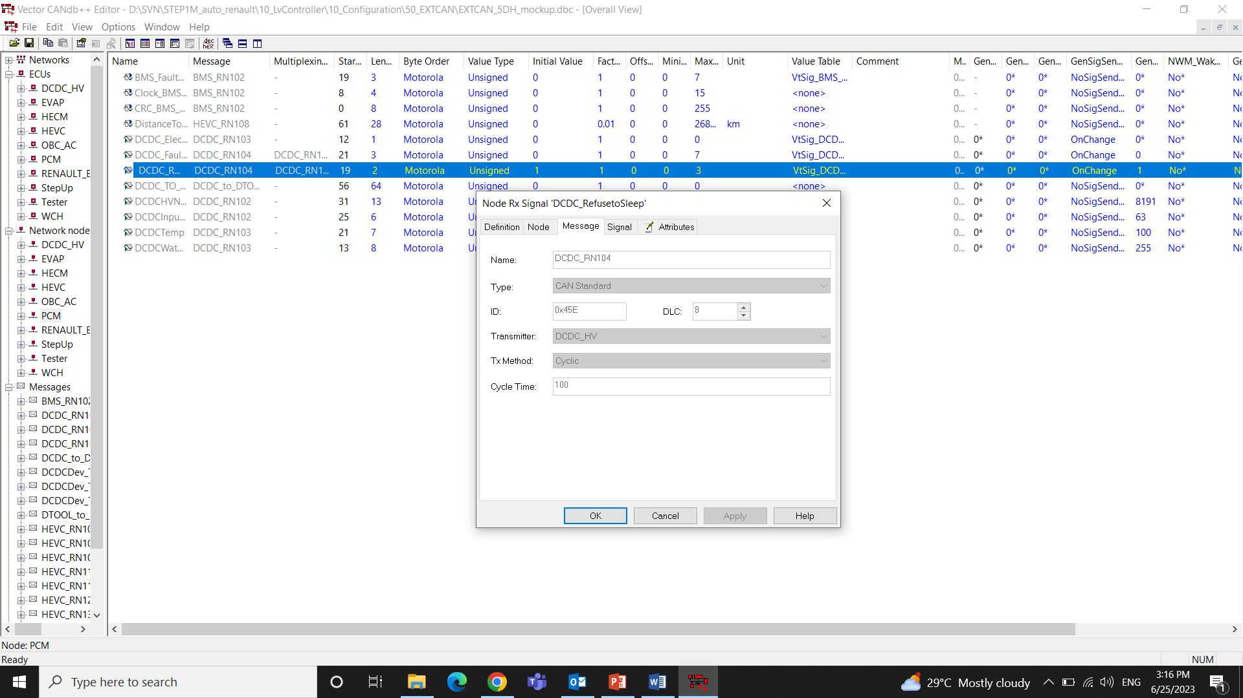

We can set the initial value, Factor, ID, DLC etc about a signal.

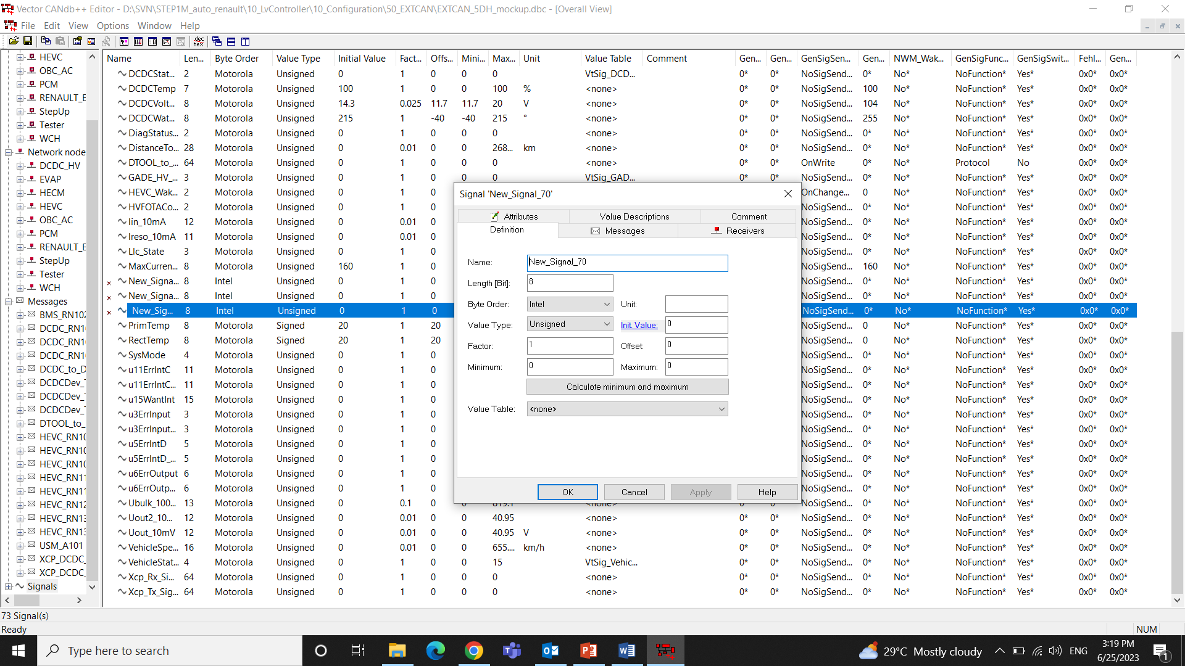

On selecting the signal menu, all the signals associated with the CAN will be listed. We can edit the signal parameters.

## 4.3 Vector CANdela Studio

It is used for creating and managing diagnostic data according to the CANdela format. CANdela is used for describing diagnostic communication between electronic control units (ECUs) and diagnostic testers.

It allows to define diagnostic data, such as diagnostic services, diagnostic parameters, fault memory, and other relevant information. The tool supports the creation and editing of diagnostic specification files in the CANdela format.

## 4.4 CDD File

A CDD (CANdela Diagnostic Data) file contains diagnostic specifications that define how diagnostic testers and tools communicate with ECUs to perform diagnostic functions. It includes information such as diagnostic services, diagnostic parameters, fault memory, communication protocols, and more.

Open RNA_5DH_DCDC.cdd from D:\SVN\STEP1M_auto_renault\10_LvController\10_Configuration\20_Candela file path.

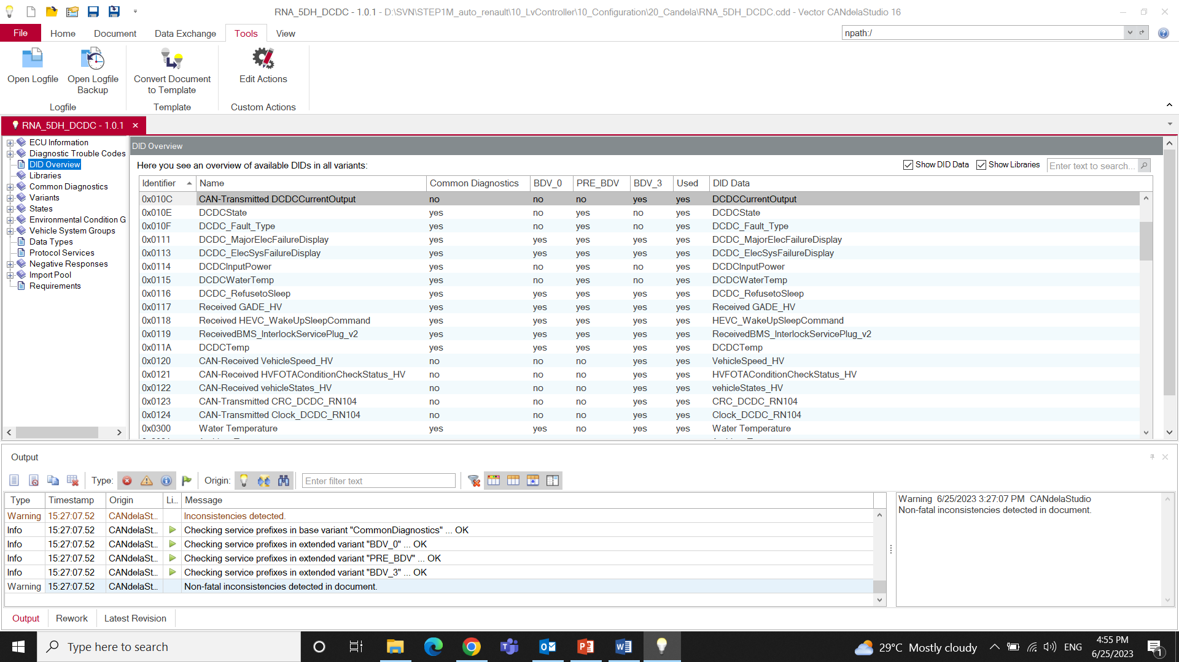

Different diagnostic specifications can be found in the left window, selecting them opens new window with its attributes.

Need to understand more from hands-on